**Joining Data in SQL**

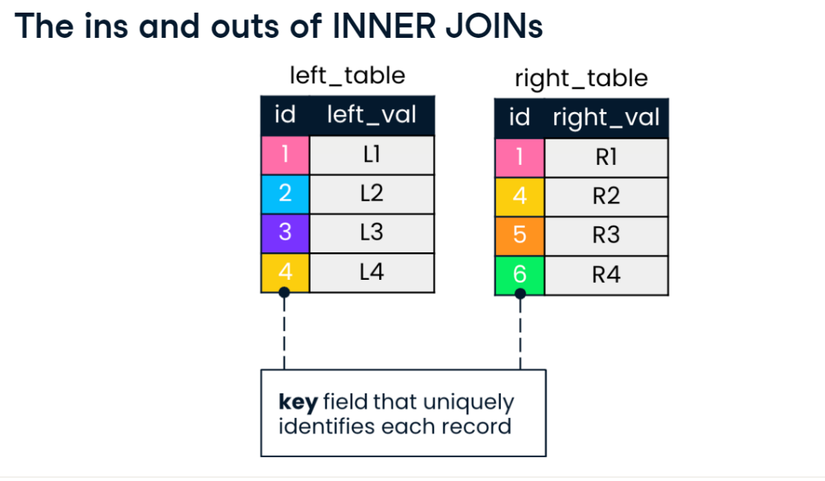

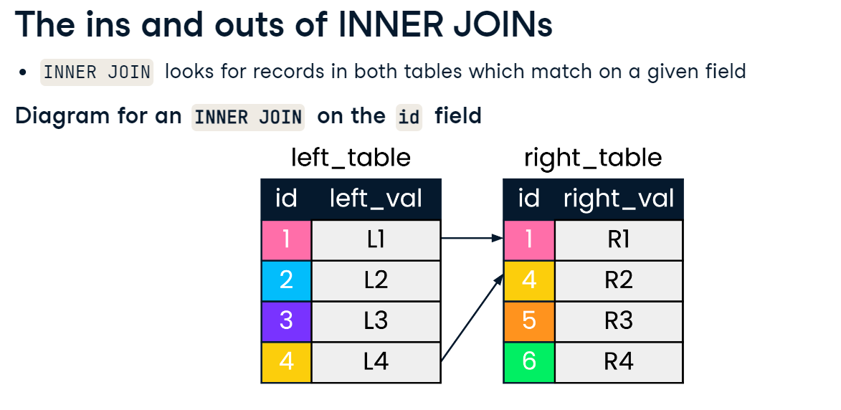

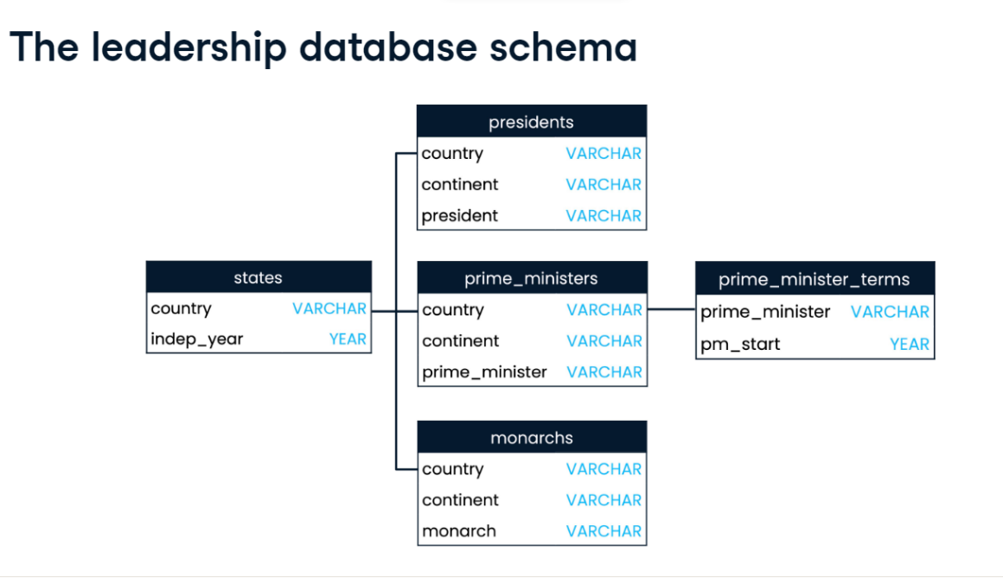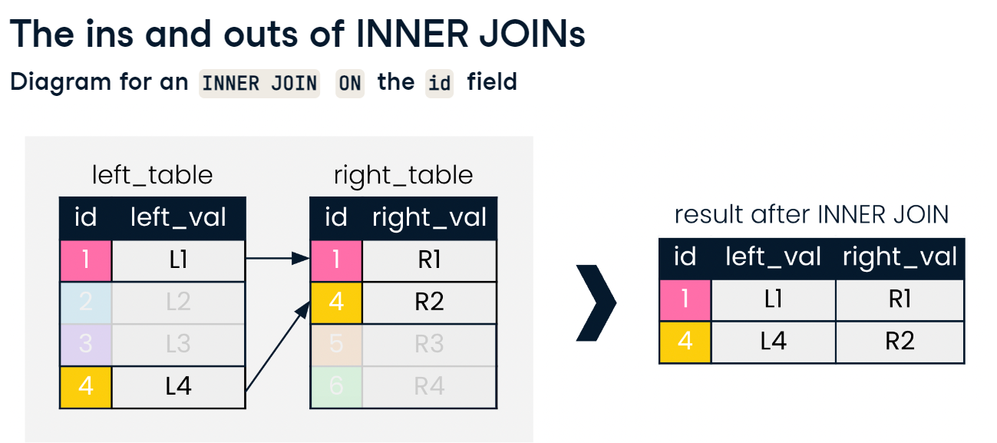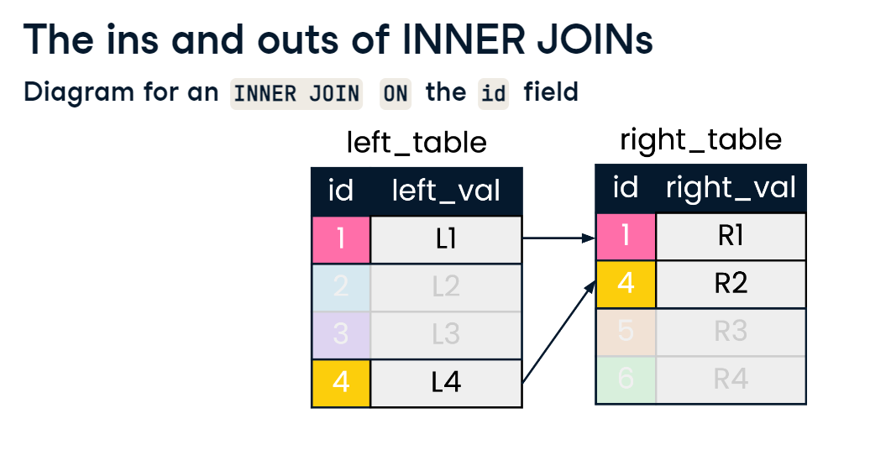

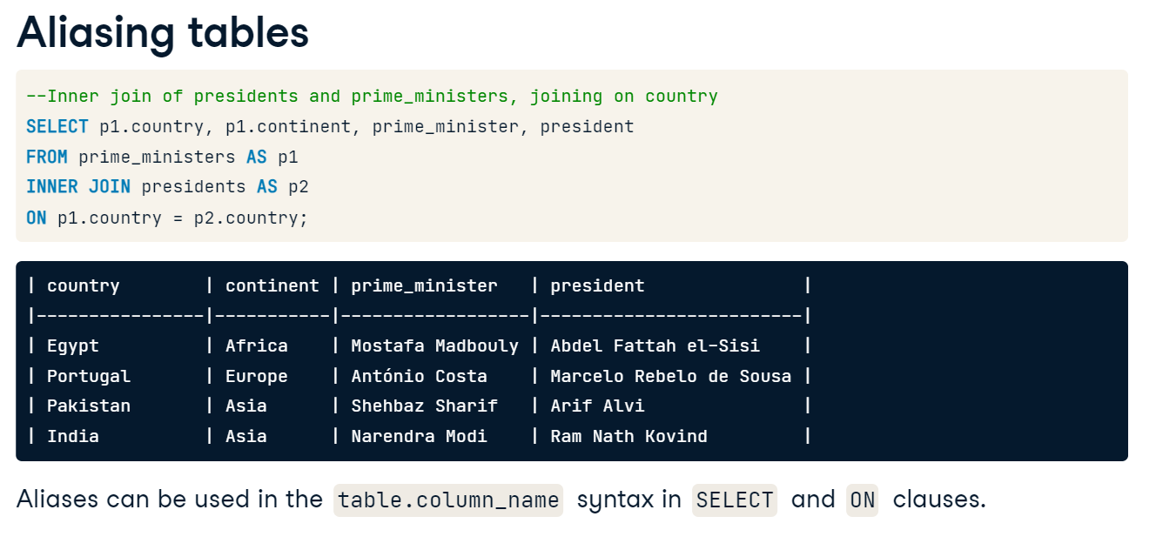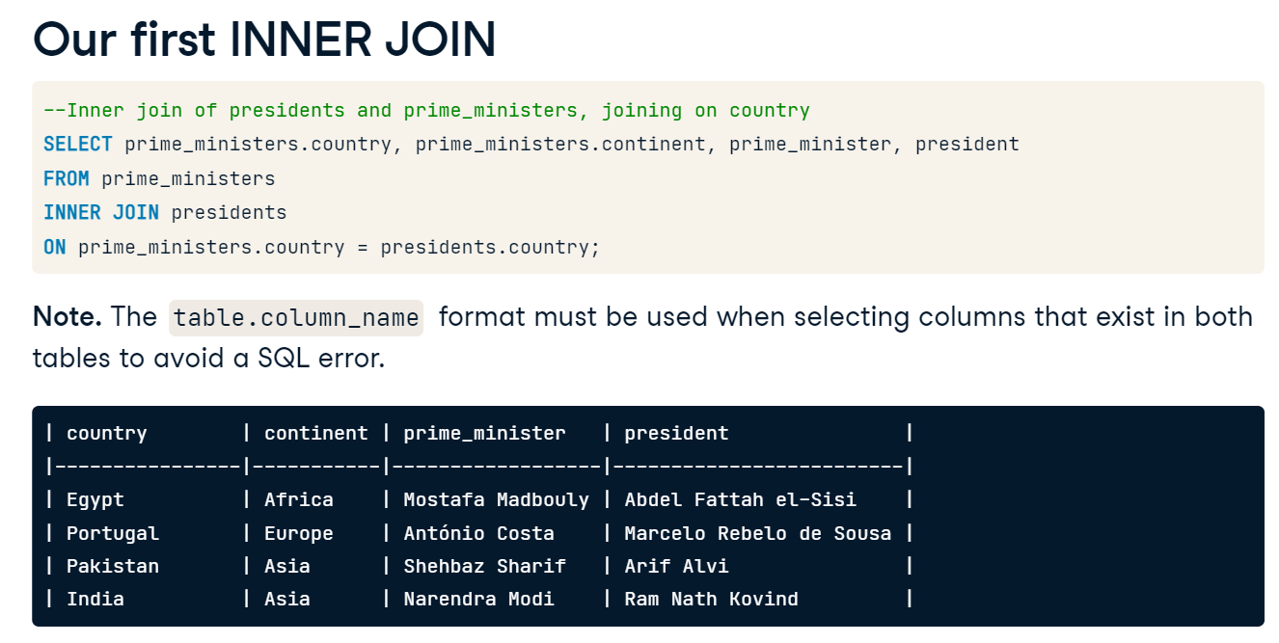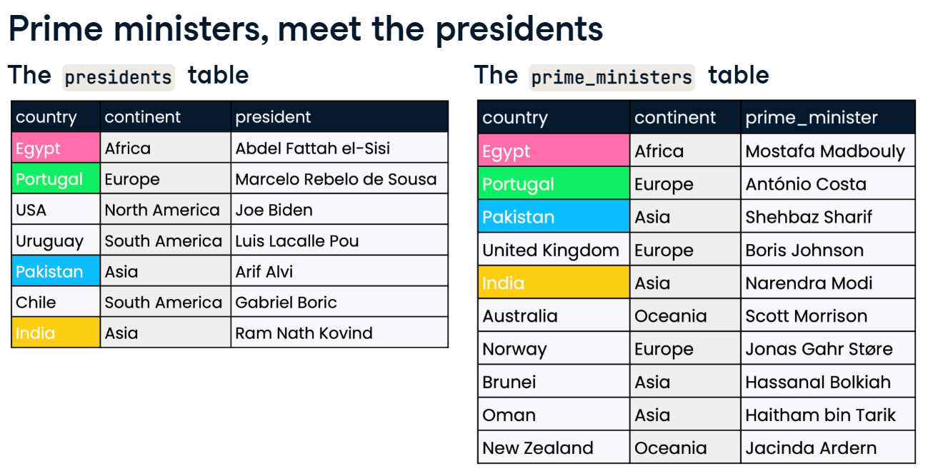

**Your first join**

Throughout this course, you'll be working with the countries database, which contains information about the most populous world cities in the world, along with country-level economic, population, and geographic data. The database also contains information on languages spoken in each country.

You can see the different tables in this database to get a sense of what they contain by clicking on the corresponding tabs. Click through them and familiarize yourself with the fields that seem to be shared across tables before you continue with the course.

In this exercise, you'll use the cities and countries tables to build your first inner join. You'll start off by selecting all columns in step 1, performing your join in step 2, and then refining your join to choose specific columns in step 3.

* Begin by selecting all columns from the cities table, using the SQL shortcut that selects all.
* -- Select all columns from cities
* SELECT *
* FROM cities;
* Identify the relevant column names to join ON by inspecting the cities and countries tabs in the console.

SELECT *

FROM cities

-- Inner join to countries

INNER JOIN countries

-- Match on country codes

ON countries.code = cities.country_code;

* Complete the SELECT statement to keep only the name of the city, the name of the country, **and** the region the country is located in (in the order specified).
* Alias the name of the city AS city and the name of the country AS country.
* -- Select name fields (with alias) and region
* SELECT ___
* FROM cities
* INNER JOIN countries
* ON cities.country_code = countries.code;

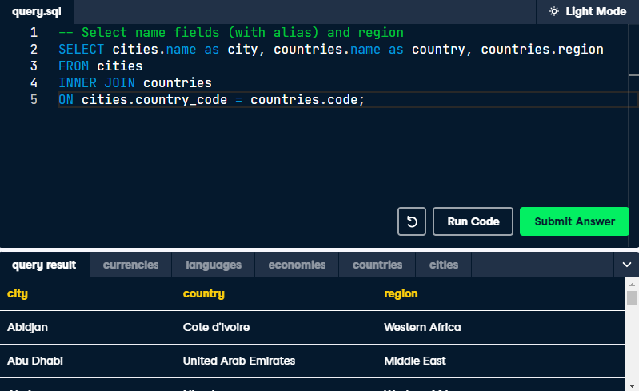

# Joining with aliased tables

Recall from the video that instead of writing full table names in queries, you can use table aliasing as a shortcut. The alias can be used in other parts of your query, such as the SELECT statement!

You also learned that when you SELECT fields, a field can be ambiguous. For example, imagine two tables, apples and oranges, both containing a column called color. You need to use the syntax apples.color or oranges.color in your SELECT statement to point SQL to the correct table. Without this, you would get the following error:

column reference "color" is ambiguous

In this exercise, you'll practice joining with aliased tables. You'll use data from both the countries and economies tables to examine the inflation rate in 2010 and 2015.

When writing joins, many SQL users prefer to write the SELECT statement after writing the join code, in case the SELECT statement requires using table aliases.

## Instructions

**100 XP**

* Start with your inner join in line 5; join the tables countries AS c (left) with economies (right), aliasing economies AS e.
* Next, use code as your joining field in line 7; do **not** use the USING command here.
* Lastly, select the following columns **in order** in line 2: code from the countries table (aliased as country_code), name, year, and inflation_rate.

1 -- Select fields with aliases

2 ___

3 FROM countries AS c

4 -- Join to economies (alias e)

5 ___

6 -- Match on code field using table aliases

7 ___

Errors:

-- Select fields with aliases

SELECT countries.code as country_code, name, year, inflation_rate

FROM countries AS c

-- Join to economies (alias e)

INNER JOIN countries AS c, economies AS e

-- Match on code field using table aliases

ON c.inflation_rate = e.inflation_rate;

yntax error at or near "," LINE 5: INNER JOIN countries AS c, economies AS e ^

-- Select fields with aliases

SELECT countries.code as country_code, name, year, inflation_rate

FROM countries AS c

-- Join to economies (alias e)

INNER JOIN  economies AS e

-- Match on code field using table aliases

ON c.inflation_rate = e.inflation_rate;

column c.inflation_rate does not exist LINE 7: ON c.inflation_rate = e.inflation_rate; ^ HINT: Perhaps you meant to reference the column "e.inflation_rate".

-- Select fields with aliases

SELECT countries.code as country_code, name, year, inflation_rate

FROM countries AS c

-- Join to economies (alias e)

INNER JOIN  economies AS e

-- Match on code field using table aliases

ON c.code = e.code;

invalid reference to FROM-clause entry for table "countries" LINE 2: SELECT countries.code as country_code, name, year, inflation... ^ HINT: Perhaps you meant to reference the table alias "c".

Correct : -- Select fields with aliases

SELECT c.code as country_code, name, year, inflation_rate

FROM countries AS c

-- Join to economies (alias e)

INNER JOIN  economies AS e

-- Match on code field using table aliases

ON c.code = e.code;

# USING in action

In the previous exercises, you performed your joins using the ON keyword. Recall that when **both** the field names being joined on are the same, you can take advantage of the USING clause.

You'll now explore the languages table from our database. Which languages are official languages, and which ones are unofficial?

You'll employ USING to simplify your query as you explore this question.

* Use the country code field to complete the INNER JOIN with USING; do **not** change any alias names.
* SELECT c.name AS country, l.name AS language, official
* FROM countries AS c
* INNER JOIN languages AS l
* -- Match using the code column
* ___

SELECT c.name AS country, l.name AS language, official

FROM countries AS c

INNER JOIN languages AS l

-- Match using the code column

using(code);

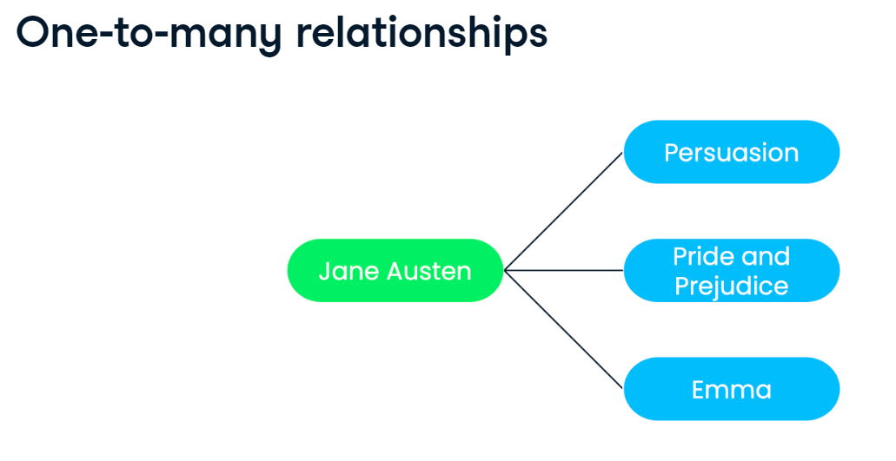



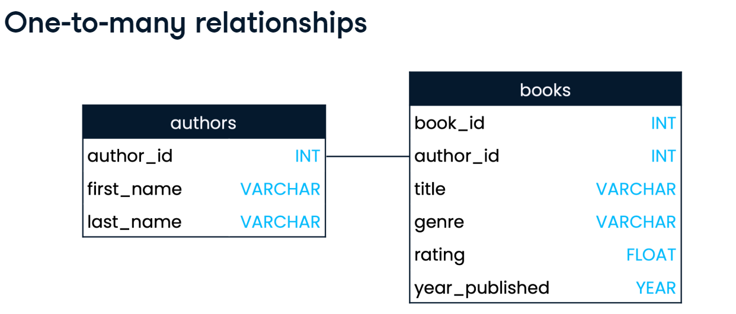

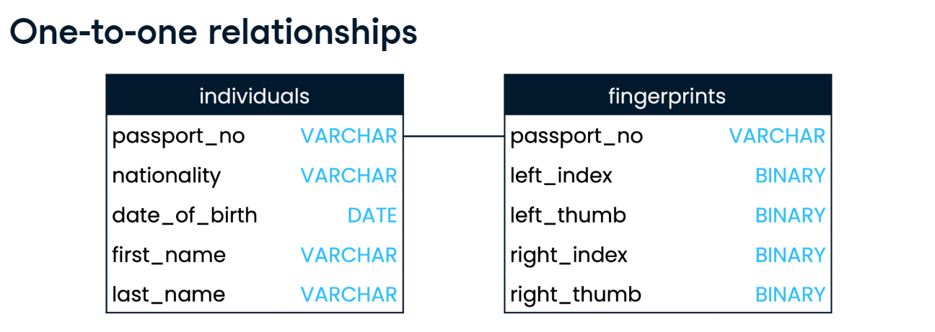

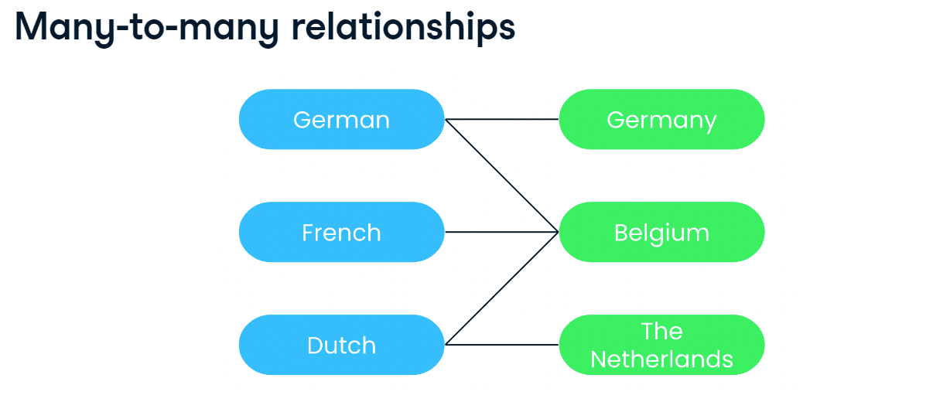

# Relationships in our database

Now that you know more about the different types of relationships that can exist between tables, it's time to examine a few relationships in the countries database!

To answer questions about table relationships, you can explore the tables displayed as tabs in your console.

## Question

What best describes the relationship between code in the countries table and country_code in the cities table?

### Possible answers



This is a many-to-many relationship.



This is a one-to-one relationship.



This is a one-to-many relationship.

Submit Answer

## Question

Which of these options best describes the relationship between the countries table and the languages table?

### Possible answers



This is a one-to-many relationship.



This is a many-to-many relationship.



This is a one-to-one relationship.

Submit Answer

# Inspecting a relationship

You've just identified that the countries table has a many-to-many relationship with the languages table. That is, many languages can be spoken in a country, and a language can be spoken in many countries.

This exercise looks at each of these in turn. First, what is the best way to query all the different languages spoken in a country? And second, how is this different from the best way to query all the countries that speak each language?

Recall that when writing joins, many users prefer to write SQL code out of order by writing the join first (along with any table aliases), and writing the SELECT statement at the end.

* Start with the join statement in line 6; perform an inner join with the countries table as c on the left with the languages table as l on the right.
* Make use of the USING keyword to join on code in line 8.
* Lastly, in line 2, select the country name, aliased as country, and the language name, aliased as language.
* -- Select country and language names, aliased
* select c.name as country, l.name as language
* -- From countries (aliased)
* FROM countries as c
* -- Join to languages (aliased)
* INNER JOIN  languages as l
* -- Use code as the joining field with the USING keyword
* using(code);
* Rearrange the SELECT statement so that the language column appears on the left and the country column on the right.
* Sort the results by language.

-- Rearrange SELECT statement, keeping aliases

SELECT l.name as language,c.name AS country

FROM countries AS c

INNER JOIN languages AS l

USING(code)

-- Order the results by language

order by language;

# Inspecting a relationship

You've just identified that the countries table has a many-to-many relationship with the languages table. That is, many languages can be spoken in a country, and a language can be spoken in many countries.

This exercise looks at each of these in turn. First, what is the best way to query all the different languages spoken in a country? And second, how is this different from the best way to query all the countries that speak each language?

Recall that when writing joins, many users prefer to write SQL code out of order by writing the join first (along with any table aliases), and writing the SELECT statement at the end.

## Question

Select the **incorrect** answer from the following options.

The query you generated in step 1 is provided below. Run this query (or the amendment you made in step 2) in the console to find the answer to the question.

SELECT c.name AS country, l.name AS language

FROM countries AS c

INNER JOIN languages AS l

USING(code)

ORDER BY country;

### Possible answers



There are at least three languages spoken in Armenia.



Alsatian is spoken in more than one country.



Bhojpuri is spoken in two countries.

Submit Answer



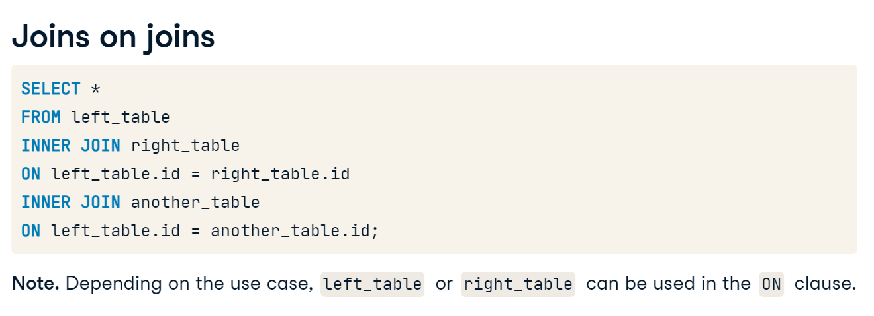

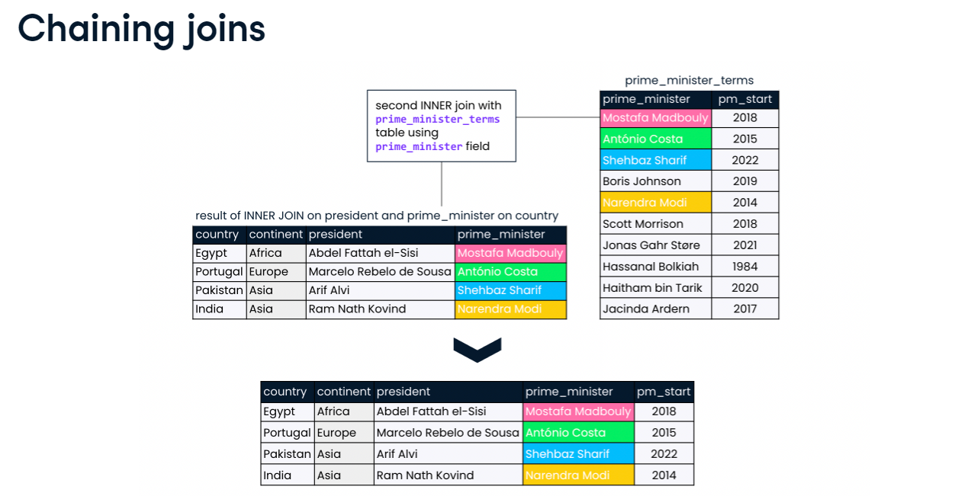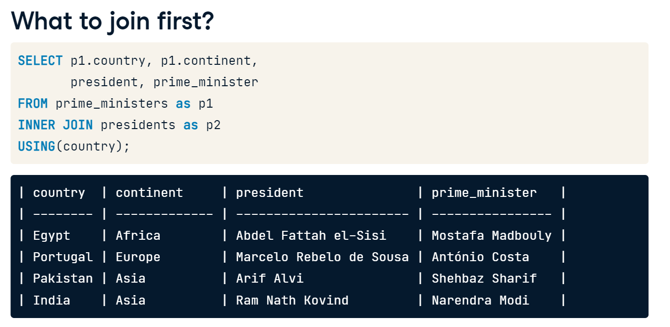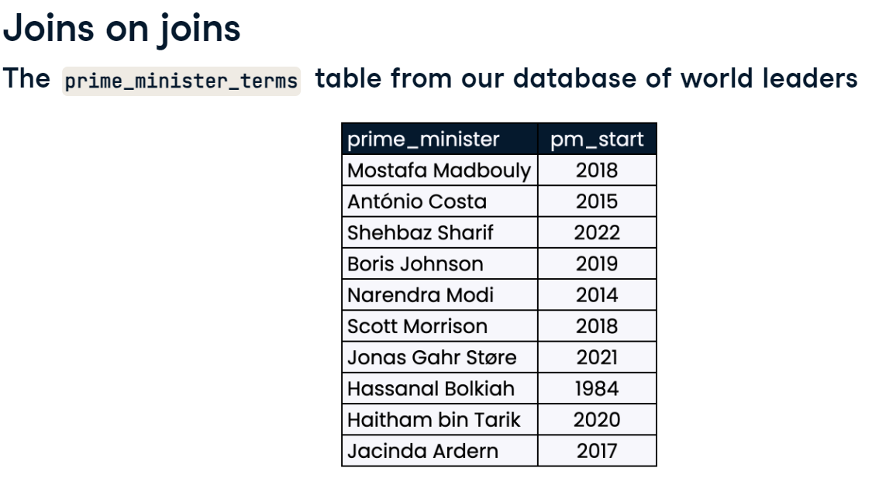

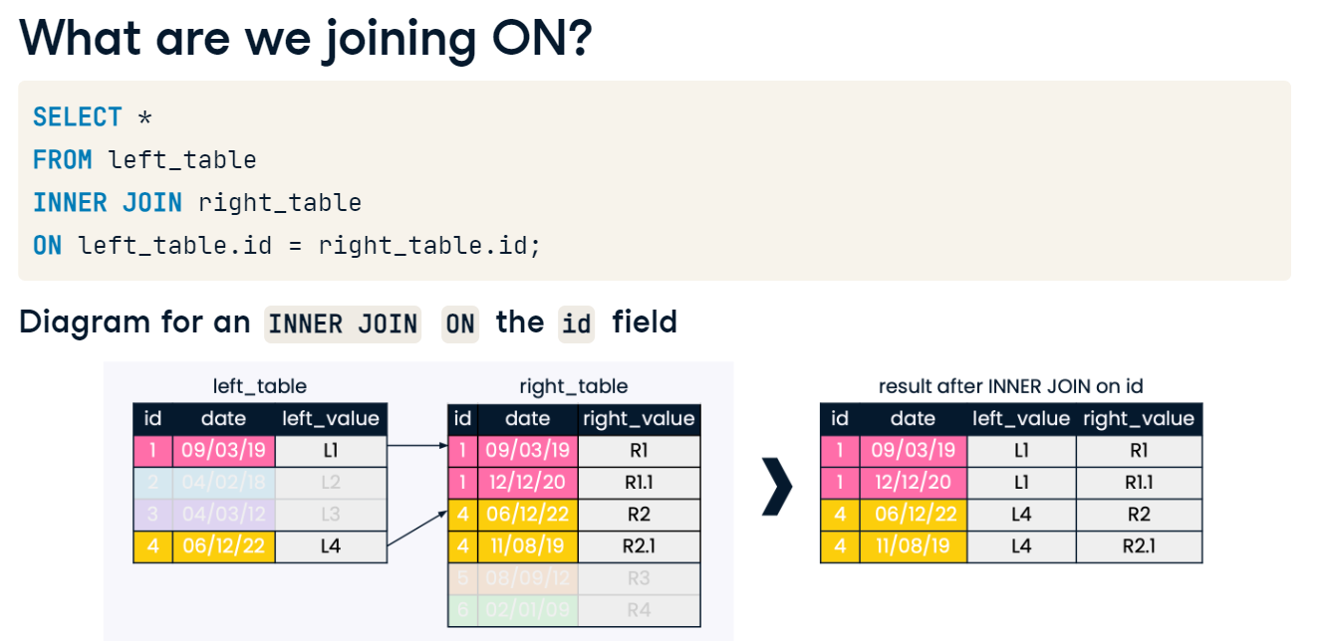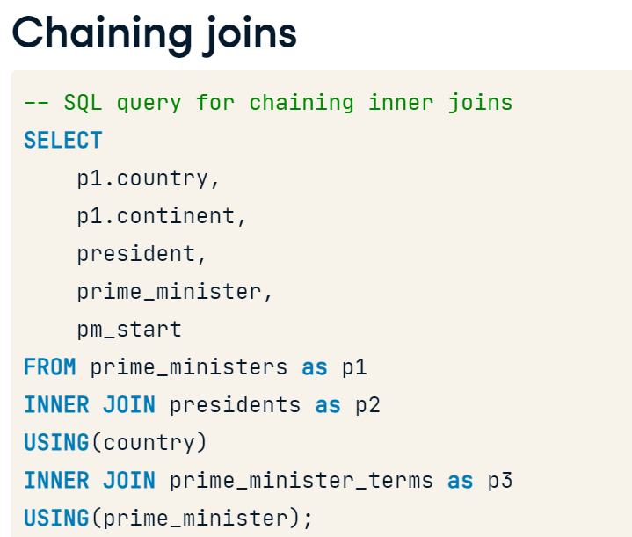

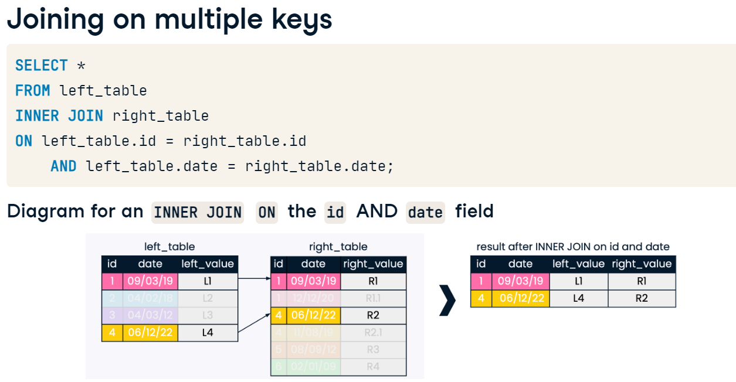

# Joining multiple tables

You've seen that the ability to combine multiple joins using a single query is a powerful feature of SQL.

Suppose you are interested in the relationship between fertility and unemployment rates. Your task in this exercise is to join tables to return the country name, year, fertility rate, and unemployment rate in a single result from the countries, populations and economies tables.

* Perform an inner join of countries AS c (left) with populations AS p (right), on code.
* Select name, year and fertility_rate.
* -- Select relevant fields
* ___
* -- Inner join countries and populations, aliased, on code
* ___

-- Select fields

SELECT name, e.year, fertility_rate, e.unemployment_rate

FROM countries AS c

INNER JOIN populations AS p

ON c.code = p.country_code

-- Join to economies (as e)

INNER join economies as e

-- Match on country code

using(code);

**Checking multi-table joins**

Have a look at the results for Albania from the previous query below. You can see that the 2015 fertility_rate has been paired with 2010 unemployment_rate, and vice versa.

| **name** | **year** | **fertility_rate** | **unemployment_rate** |
| --- | --- | --- | --- |
| Albania | 2015 | 1.663 | 17.1 |
| Albania | 2010 | 1.663 | 14 |
| Albania | 2015 | 1.793 | 17.1 |
| Albania | 2010 | 1.793 | 14 |

Instead of four records, the query should return two: one for each year. The last join was performed on c.code = e.code, without also joining on year. Your task in this exercise is to fix your query by explicitly stating that *both* the country code *and* year should match!

* Modify your query so that you are joining to economies on year as well as code.
* SELECT name, e.year, fertility_rate, unemployment_rate
* FROM countries AS c
* INNER JOIN populations AS p
* ON c.code = p.country_code
* INNER JOIN economies AS e
* ON c.code = e.code
* -- Add an additional joining condition such that you are also joining on year
* ___;

SELECT name, e.year, fertility_rate, unemployment_rate

FROM countries AS c

INNER JOIN populations AS p

ON c.code = p.country_code

INNER JOIN economies AS e

ON c.code = e.code

-- Add an additional joining condition such that you are also joining on year

    AND e.year=p.year;

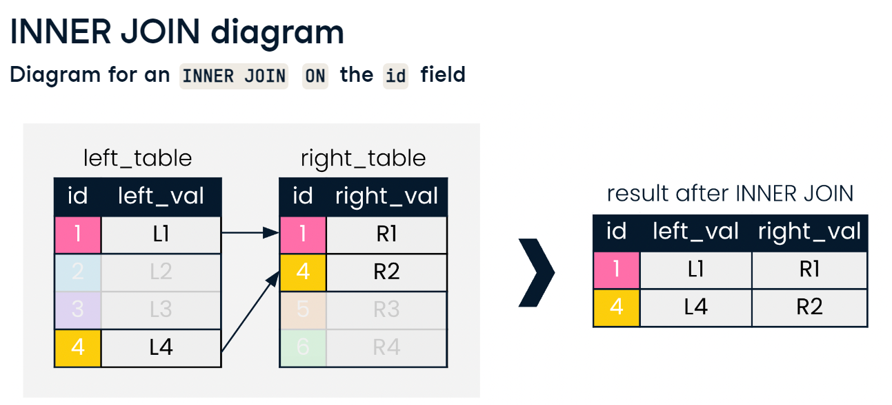

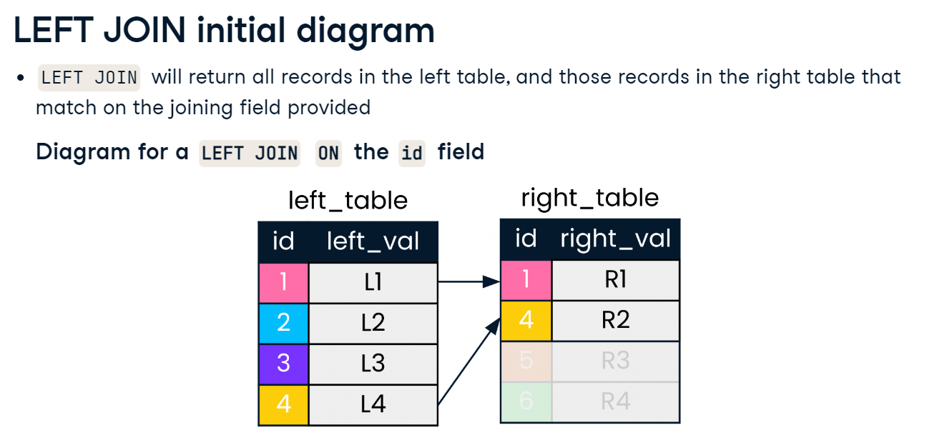

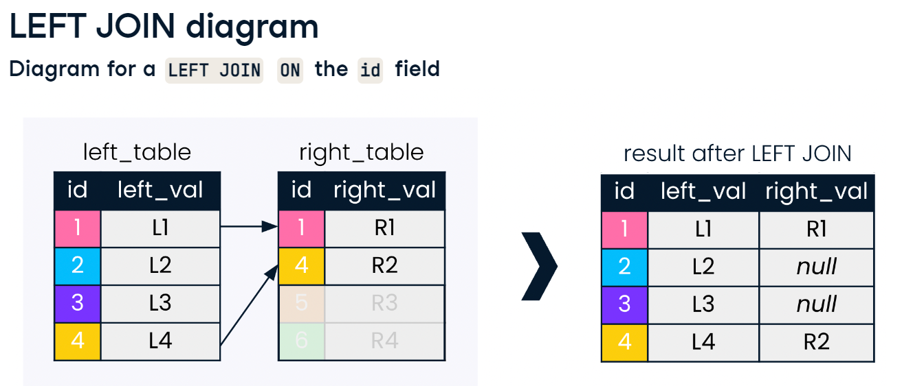

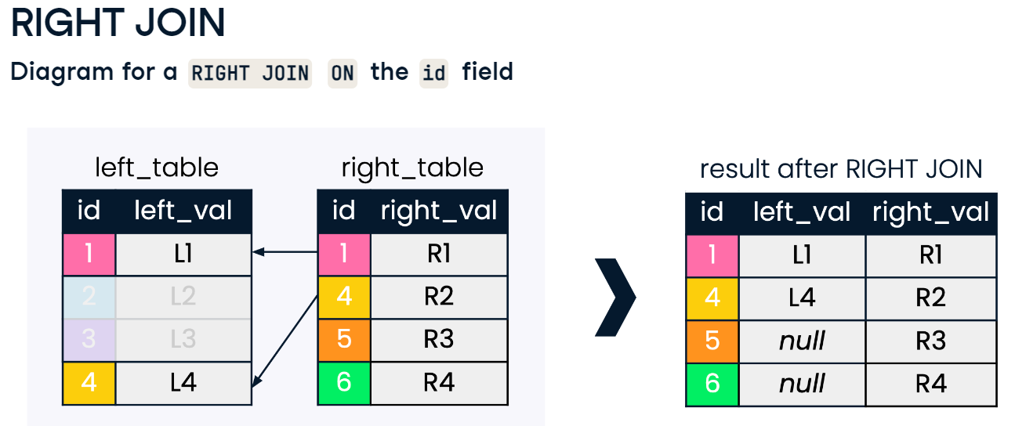 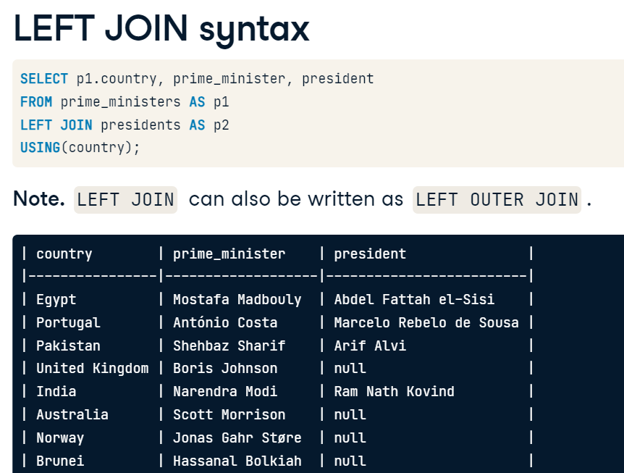

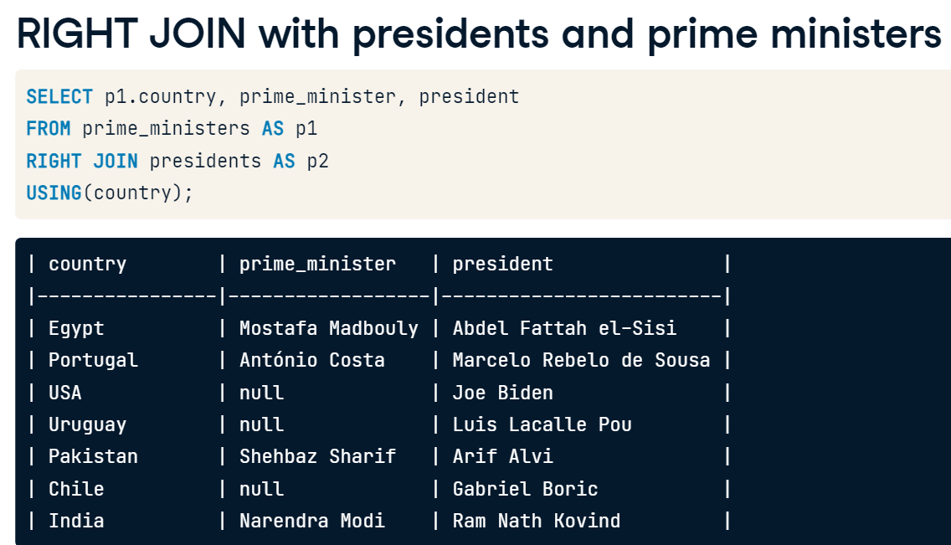

# This is a LEFT JOIN, right?

Nice work getting to grips with the structure of joins! In this exercise, you'll explore the differences between INNER JOIN and LEFT JOIN. This will help you decide which type of join to use.

As before, you will be using the cities and countries tables.

You'll begin with an INNER JOIN with the cities table (left) and countries table (right). This helps if you are interested only in records where a country is present in both tables.

You'll then change to a LEFT JOIN. This helps if you're interested in returning all countries in the cities table, whether or not they have a match in the countries table.

* Perform an inner join with cities AS c1 on the left and countries as c2 on the right.
* Use code as the field to merge your tables on.
* SELECT
* c1.name AS city,
* code,
* c2.name AS country,
* region,
* city_proper_pop
* FROM cities AS c1
* -- Perform an inner join with cities as c1 and countries as c2 on country code
* inner join countries as c2
* on c1.country_code = c2.code
* ORDER BY code DESC;
* Change the code to perform a LEFT JOIN instead of an INNER JOIN.
* After executing this query, have a look at how many records the query result contains.

SELECT

    c1.name AS city,

    code,

    c2.name AS country,

    region,

    city_proper_pop

FROM cities AS c1

-- Join right table (with alias)

left join countries as c2

ON c1.country_code = c2.code

ORDER BY code DESC;

# Building on your LEFT JOIN

You'll now revisit the use of the AVG() function introduced in a previous course.

Being able to build more than one SQL function into your query will enable you to write compact, supercharged queries.

You will use AVG() in combination with a LEFT JOIN to determine the average gross domestic product (GDP) per capita **by region** in 2010.

* Complete the LEFT JOIN with the countries table on the left and the economies table on the right on the code field.
* Filter the records from the year 2010.

SELECT name, region, gdp_percapita

FROM countries AS c

LEFT JOIN economies AS e

-- Match on code fields

___

-- Filter for the year 2010

___;

SELECT name, region, gdp_percapita

FROM countries AS c

LEFT JOIN economies AS e

-- Match on code fields

using (code)

-- Filter for the year 2010

where year= 2010;

* To calculate per capita GDP per region, begin by grouping by region.
* After your GROUP BY, choose region in your SELECT statement, followed by average GDP per capita using the AVG() function, with AS avg_gdp as your alias.
* -- Select region, and average gdp_percapita as avg_gdp
* ___
* FROM countries AS c
* LEFT JOIN economies AS e
* USING(code)
* WHERE year = 2010
* -- Group by region
* GROUP BY ___;

-- Select region, and average gdp_percapita as avg_gdp

select region, avg(e.gdp_percapita) as avg_gdp

FROM countries AS c

LEFT JOIN economies AS e

USING(code)

WHERE year = 2010

-- Group by region

GROUP BY region;

* Order the result set by the average GDP per capita from highest to lowest.
* Return only the first 10 records in your result.
* SELECT region, AVG(gdp_percapita) AS avg_gdp
* FROM countries AS c
* LEFT JOIN economies AS e
* USING(code)
* WHERE year = 2010
* GROUP BY region
* -- Order by descending avg_gdp
* order by (avg_gdp) DESC
* -- Return only first 10 records
* limit 10;

# Is this RIGHT?

You learned that right joins are not used as commonly as left joins. A key reason for this is that right joins can always be re-written as left joins, and because joins are typically typed from left to right, joining from the left feels more intuitive when constructing queries.

It can be tricky to wrap one's head around when left and right joins return equivalent results. You'll explore this in this exercise!

* Write a new query using RIGHT JOIN that produces an identical result to the LEFT JOIN provided.
* -- Modify this query to use RIGHT JOIN instead of LEFT JOIN
* SELECT countries.name AS country, languages.name AS language, percent
* FROM countries
* LEFT JOIN languages
* USING(code)
* ORDER BY language;

Incorrect

SELECT countries.name AS country, languages.name AS language, percent

FROM countries

RIGHT JOIN languages

on languages.code=countries.code

ORDER BY language;

Correct

-- Modify this query to use RIGHT JOIN instead of LEFT JOIN

SELECT countries.name AS country, languages.name AS language, percent

FROM languages

RIGHT JOIN countries

ON languages.code = countries.code

ORDER BY language;

Last type of the outer join



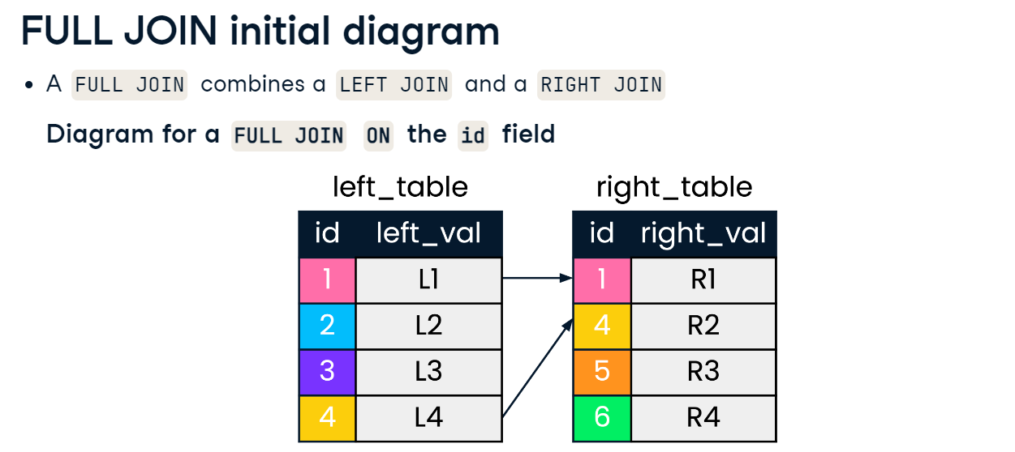

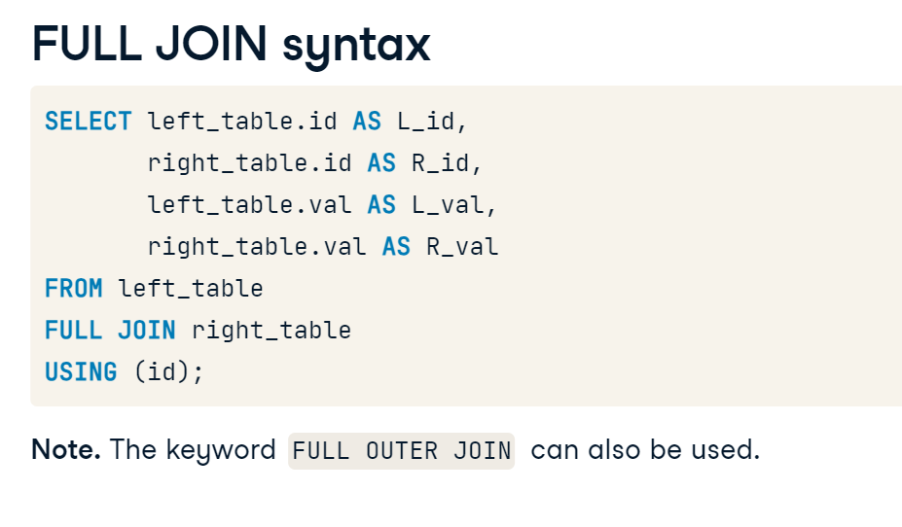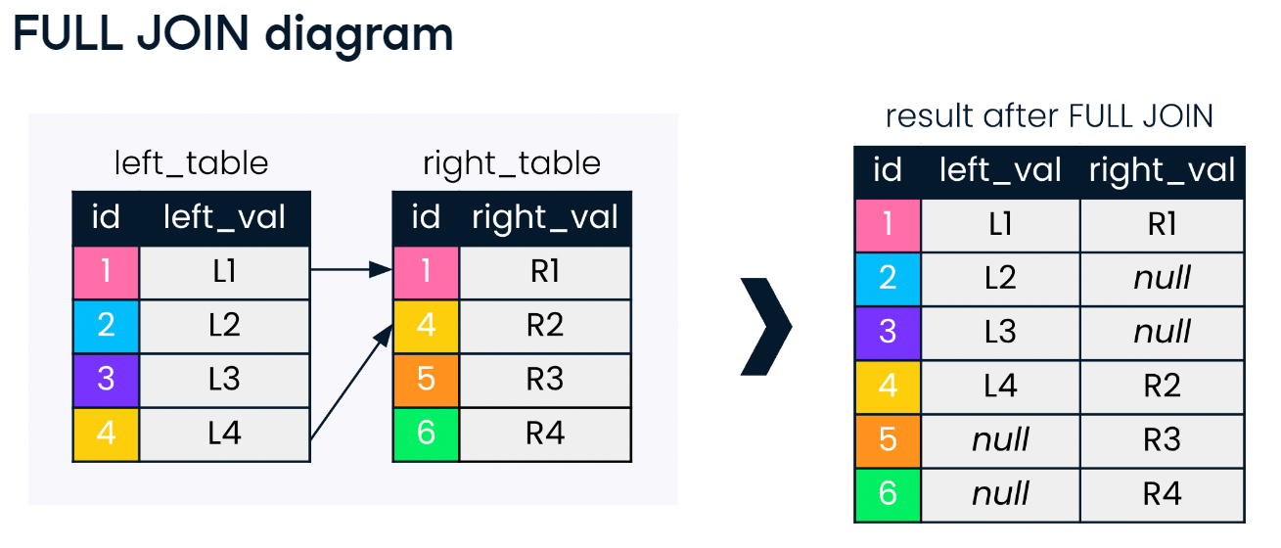

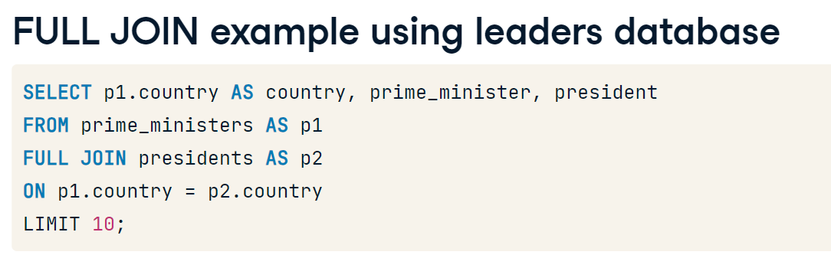

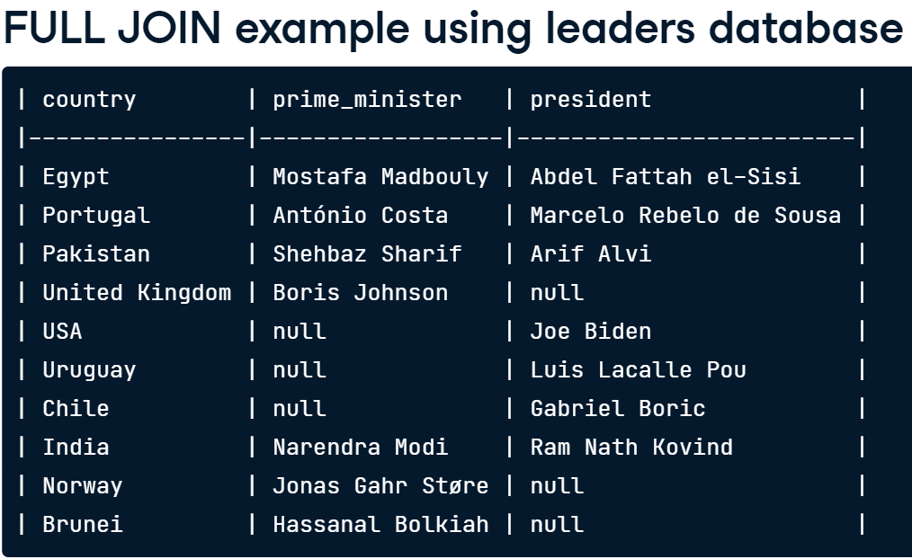

# Comparing joins

In this exercise, you'll examine how results can differ when performing a full join compared to a left join and inner join by joining the countries and currencies tables. You'll be focusing on the North American region and records where the name of the country is missing.

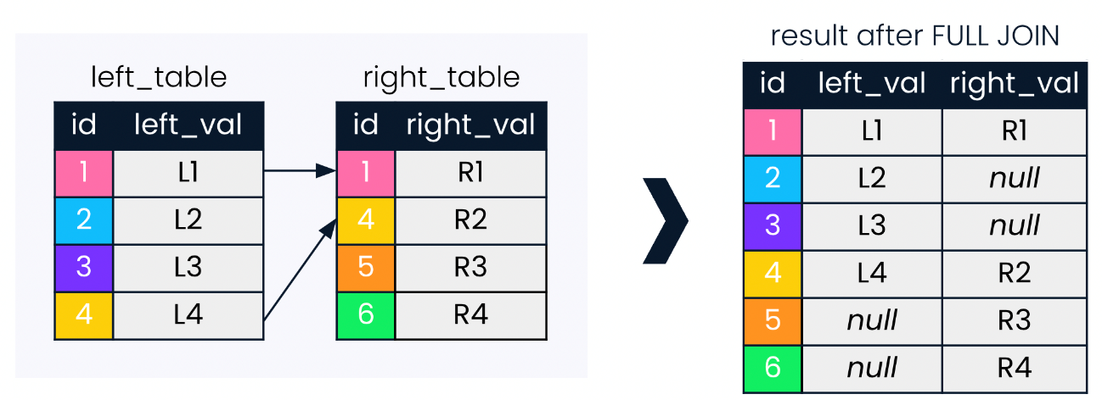You'll begin with a full join with countries on the left and currencies on the right. Recall the workings of a full join with the diagram below!

You'll then complete a similar left join and conclude with an inner join, observing the results you see along the way.

* + Perform a full join with countries (left) and currencies (right).
  + Filter for the North America region or NULL country names.

**Take Hint (-10 XP)**

**[2](javascript:void(0))**

* + Repeat the same query as before, turning your full join into a left join with the currencies table.
  + Have a look at what has changed in the output by comparing it to the full join result.

**[3](javascript:void(0))**

* + Repeat the same query again, this time performing an inner join of countries with currencies.
  + Have a look at what has changed in the output by comparing it to the full join *and* left join results!

SELECT name AS country, code, region, basic_unit

FROM countries

-- Join to currencies

___

USING (code)

-- Where region is North America or name is null

WHERE ___

ORDER BY region;

SELECT name AS country, code, region, basic_unit

FROM countries

-- Join to currencies

FULL JOIN currencies

USING (code)

-- Where region is North America or name is null

WHERE region = 'North America' OR region is null

ORDER BY region;

SELECT name AS country, code, region, basic_unit

FROM countries

-- Join to currencies

left join currencies

USING (code)

WHERE region = 'North America'

    OR name IS NULL

ORDER BY region;

SELECT name AS country, code, region, basic_unit

FROM countries

-- Join to currencies

inner join currencies

USING (code)

WHERE region = 'North America'

    OR name IS NULL

ORDER BY region;

# Chaining FULL JOINs

As you have seen in the previous chapter on INNER JOIN, it is possible to chain joins in SQL, such as when looking to connect data from more than two tables.

Suppose you are doing some research on Melanesia and Micronesia, and are interested in pulling information about languages and currencies into the data we see for these regions in the countries table. Since languages and currencies exist in separate tables, this will require two consecutive full joins involving the countries, languages and currencies tables.

* Complete the FULL JOIN with countries as c1 on the left and languages as l on the right, using code to perform this join.
* Next, chain this join with another FULL JOIN, placing currencies on the right, joining on code again.
* SELECT
* c1.name AS country,
* region,
* l.name AS language,
* basic_unit,
* frac_unit
* FROM countries as c1
* -- Full join with languages (alias as l)
* FULL JOIN languages as l
* using (code)
* -- Full join with currencies (alias as c2)
* Full join currencies as c2
* using(code)
* WHERE region LIKE 'M%esia';

# Histories and languages

Well done getting to know all about CROSS JOIN! As you have learned, CROSS JOIN can be incredibly helpful when asking questions that involve looking at all possible combinations or pairings between two sets of data.

Imagine you are a researcher interested in the languages spoken in two countries: Pakistan and India. You are interested in asking:

1. What are the languages presently spoken in the two countries?
2. Given the shared history between the two countries, what languages could potentially have been spoken in either country over the course of their history?

In this exercise, we will explore how INNER JOIN and CROSS JOIN can help us answer these two questions, respectively.

* Complete the code to perform an INNER JOIN of countries AS c with languages AS l using the code field to obtain the languages *currently* spoken in the two countries.
* SELECT c.name AS country, l.name AS language
* -- Inner join countries as c with languages as l on code
* ___
* WHERE c.code IN ('PAK','IND')
* AND l.code in ('PAK','IND');

SELECT c.name AS country, l.name AS language

-- Inner join countries as c with languages as l on code

from countries as c

Inner join languages as l

using(code)

WHERE c.code IN ('PAK','IND')

    AND l.code in ('PAK','IND');

* Change your INNER JOIN to a different kind of join to look at possible combinations of languages that *could* have been spoken in the two countries given their history.
* Observe the differences in output for both joins.

SELECT c.name AS country, l.name AS language

FROM countries AS c

-- Perform a cross join to languages (alias as l)

cross join languages as l

WHERE c.code in ('PAK','IND')

    AND l.code in ('PAK','IND');

# Choosing your join

Now that you're fully equipped to use joins, try a challenge problem to test your knowledge!

You will determine the names of the five countries and their respective regions with the lowest life expectancy for the year 2010. Use your knowledge about joins, filtering, sorting and limiting to create this list!

* Complete the join of countries AS c with populations as p.
* Filter on the year 2010.
* Sort your results by life expectancy in ascending order.
* Limit the result to five countries.
* SELECT
* c.name AS country,
* region,
* life_expectancy AS life_exp
* FROM countries AS c
* -- Join to populations (alias as p) using an appropriate join
* ___
* ON c.code = p.country_code
* -- Filter for only results in the year 2010
* ___
* -- Sort by life_exp
* ___
* -- Limit to five records
* ___;

SELECT

    c.name AS country,

    region,

    life_expectancy AS life_exp

FROM countries AS c

-- Join to populations (alias as p) using an appropriate join

left join populations as p

ON c.code = p.country_code

-- Filter for only results in the year 2010

where year = 2010

-- Sort by life_exp

ORDER BY life_exp

-- Limit to five records

limit 5;



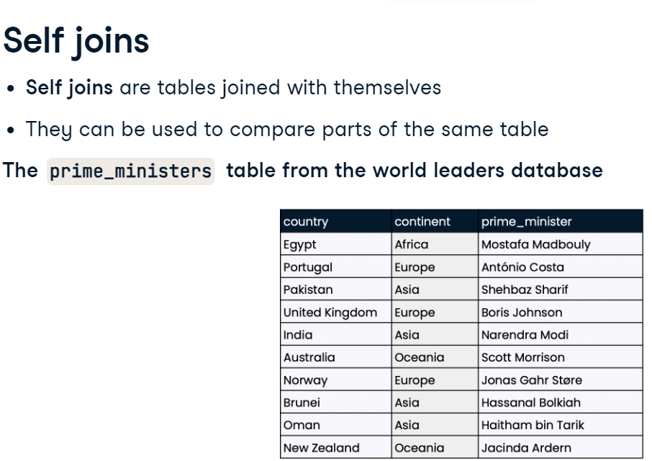

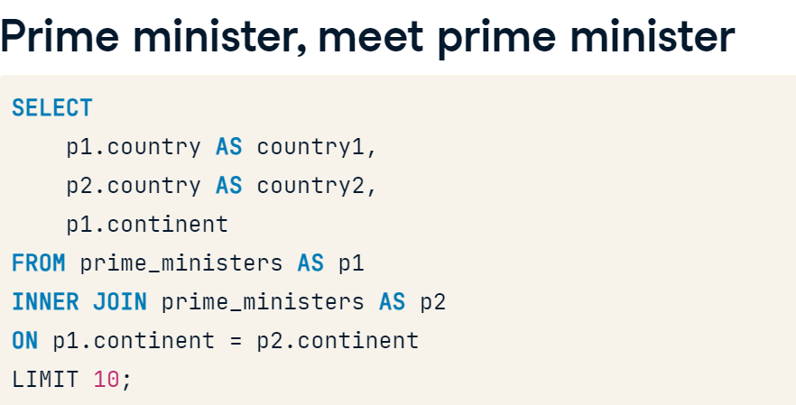

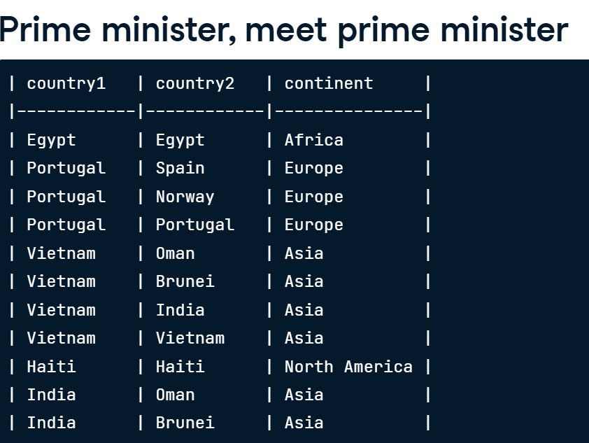

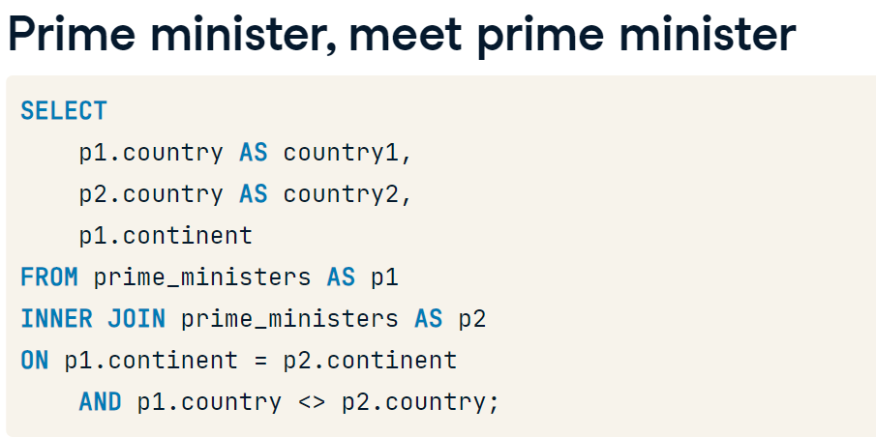

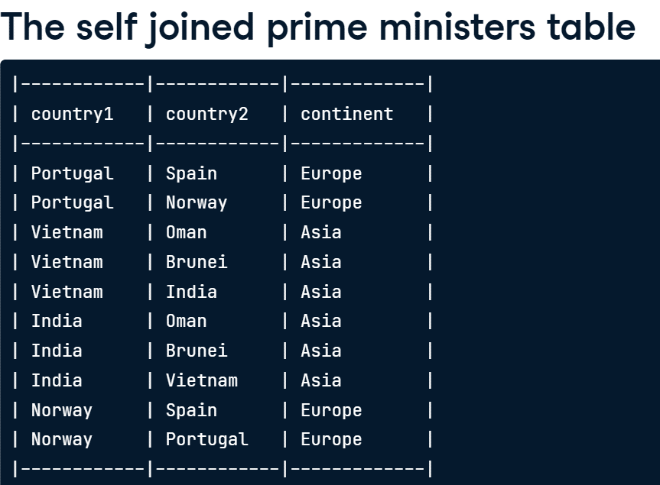

# Comparing a country to itself

Self joins are very useful for comparing data from one part of a table with another part of the same table. Suppose you are interested in finding out how much the populations for each country changed from 2010 to 2015. You can visualize this change by performing a self join.

In this exercise, you'll work to answer this question by joining the populations table with itself. Recall that, with self joins, tables must be aliased. Use this as an opportunity to practice your aliasing!

Since you'll be joining the populations table to itself, you can alias populations first as p1 and again as p2. This is good practice whenever you are aliasing tables with the same first letter.

* Perform an inner join of populations with itself ON country_code, aliased p1 and p2 respectively.
* Select the country_code from p1 and the size field from both p1 and p2, aliasing p1.size as size2010 and p2.size as size2015 (in that order).

SELECT p1.country_code, p1.size AS size2010, p2.size AS size2015

FROM populations AS p1

INNER JOIN populations AS p2

ON p1.country_code = p2.country_code;

# Comparing a country to itself

Self joins are very useful for comparing data from one part of a table with another part of the same table. Suppose you are interested in finding out how much the populations for each country changed from 2010 to 2015. You can visualize this change by performing a self join.

In this exercise, you'll work to answer this question by joining the populations table with itself. Recall that, with self joins, tables must be aliased. Use this as an opportunity to practice your aliasing!

Since you'll be joining the populations table to itself, you can alias populations first as p1 and again as p2. This is good practice whenever you are aliasing tables with the same first letter.

* Since you want to compare records from 2010 and 2015, eliminate unwanted records by extending the WHERE statement to include only records where the p1.year matches p2.year - 5.
* SELECT
* p1.country_code,
* p1.size AS size2010,
* p2.size AS size2015
* FROM populations AS p1
* INNER JOIN populations AS p2
* ON p1.country_code = p2.country_code
* WHERE p1.year = 2010
* -- Filter such that p1.year is always five years before p2.year
* ___

SELECT

    p1.country_code,

    p1.size AS size2010,

    p2.size AS size2015

FROM populations AS p1

INNER JOIN populations AS p2

ON p1.country_code = p2.country_code

WHERE p1.year = 2010

-- Filter such that p1.year is always five years before p2.year

    and p2.year-5=2010;







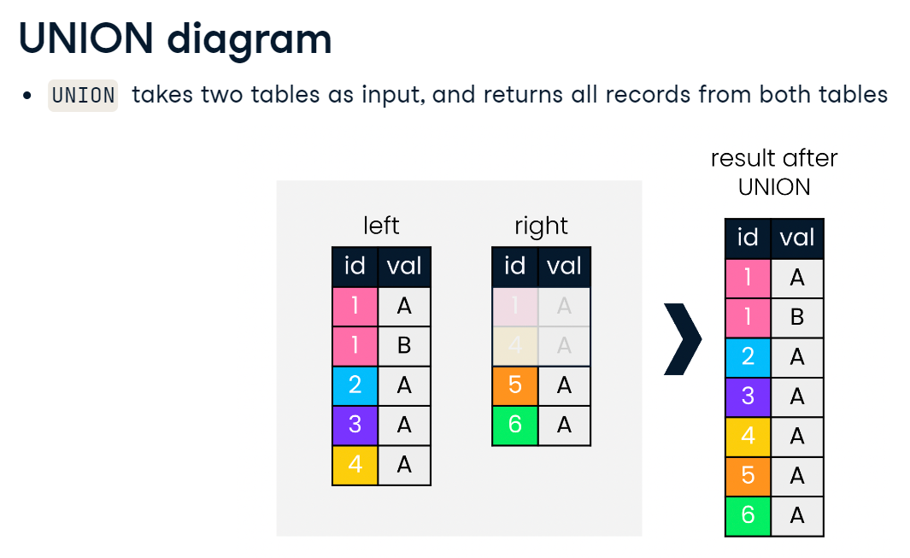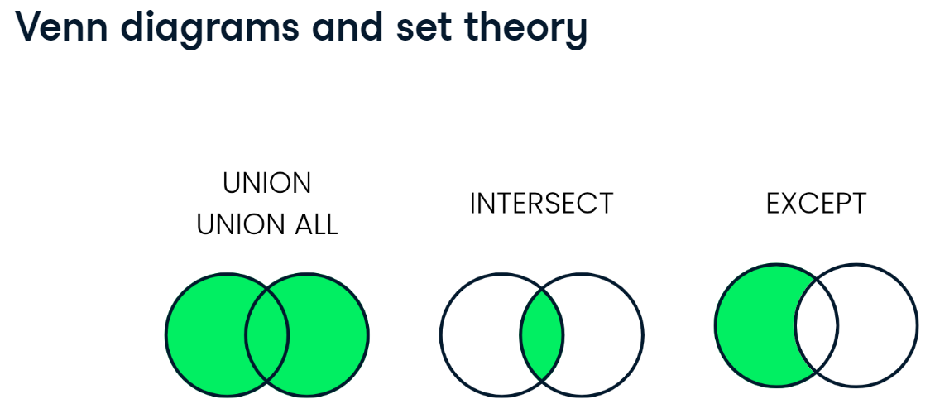

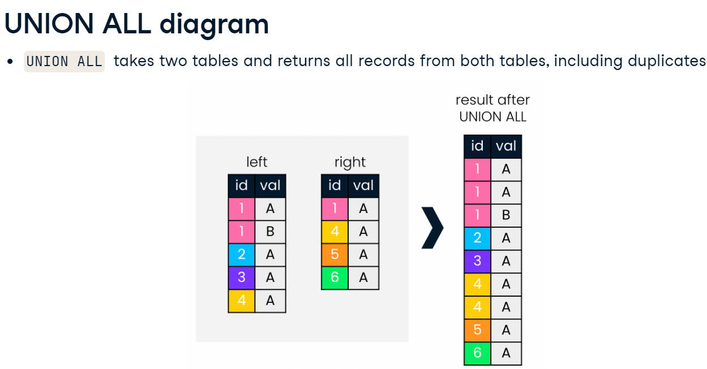

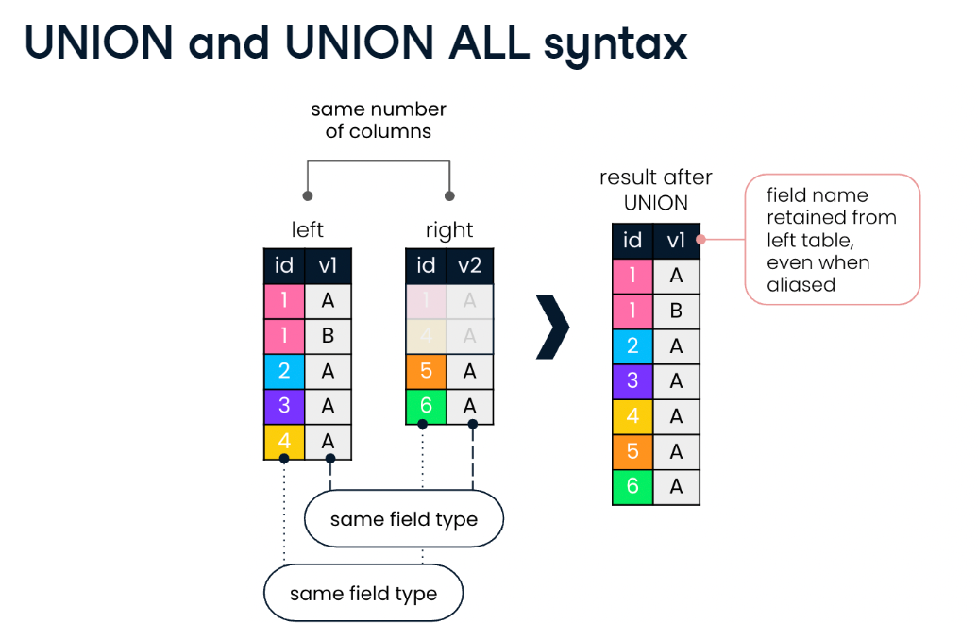

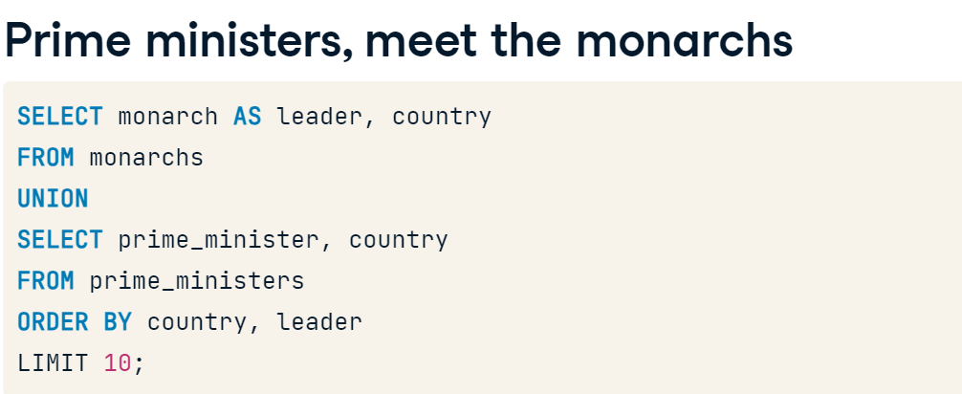

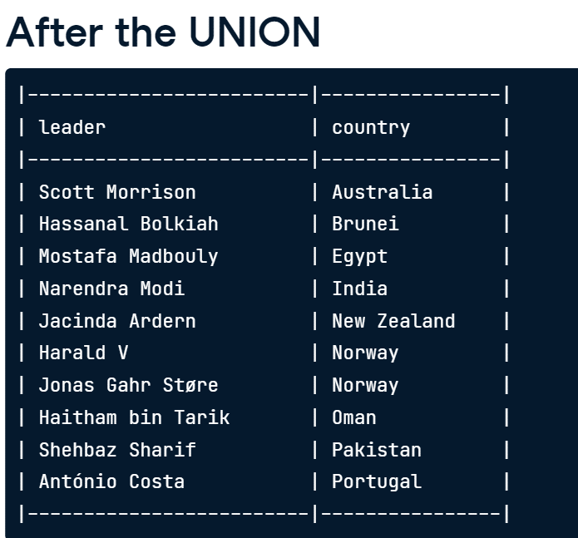

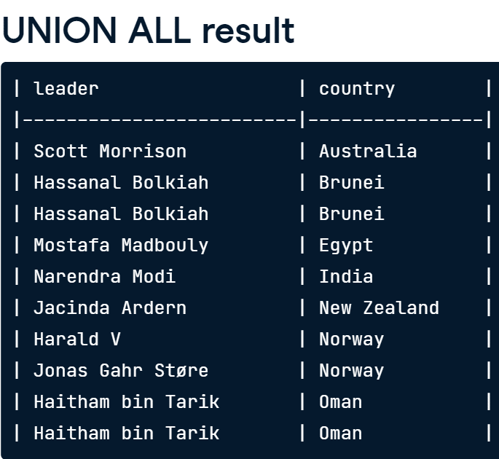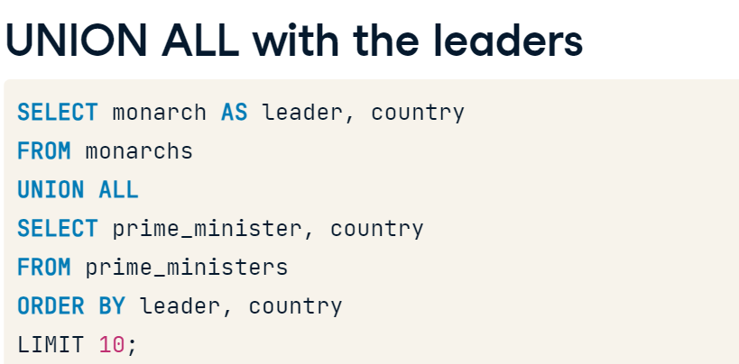

# UNION vs. UNION ALL

Nice work learning all about UNION and UNION ALL!

Two tables, languages and currencies, are provided. Run the queries provided in the console and select the correct answer for the multiple-choice questions in this exercise.

## Question

What result will the following SQL query produce?

SELECT *

FROM languages

UNION

SELECT *

FROM currencies;

### Possible answers



All records from both tables, dropping duplicate records (if any)



A SQL error, because languages and currencies do not have the same number of fields



A SQL error, because languages and currencies do not have the same number of records

Submit Answer

# UNION vs. UNION ALL

Nice work learning all about UNION and UNION ALL!

Two tables, languages and currencies, are provided. Run the queries provided in the console and select the correct answer for the multiple-choice questions in this exercise.

## Question

What result will the following SQL query produce?

SELECT *

FROM languages

UNION

SELECT *

FROM currencies;

### Possible answers



All records from both tables, dropping duplicate records (if any)



A SQL error, because languages and currencies do not have the same number of fields



A SQL error, because languages and currencies do not have the same number of records

Submit Answer

* each UNION query must have the same number of columns LINE 4: SELECT * ^

SELECT code

    FROM languages

    UNION ALL

    SELECT code FROM

    currencies;

### Possible answers

An unordered list of each country code in languages and currencies, including duplicates

select code

    from languages

    union

    select curr_id

    from currencies;

A SQL error, because code and curr_id are not of the same data type.

# Comparing global economies

Are you ready to perform your first set operation?

In this exercise, you have two tables, economies2015 and economies2019, available to you under the tabs in the console. You'll perform a set operation to stack all records in these two tables on top of each other, **excluding duplicates**.

When drafting queries containing set operations, it is often helpful to write the queries on either side of the operation first, and then call the set operator. The instructions are ordered accordingly.

* Begin your query by selecting all fields from economies2015.
* Create a second query that selects all fields from economies2019.
* Perform a set operation to combine the two queries you just created, ensuring you do **not** return duplicates.
* -- Select all fields from economies2015
* ___
* -- Set operation
* ___
* -- Select all fields from economies2019
* ___
* ORDER BY code, year;

-- Select all fields from economies2015

SELECT *

FROM economies2015

-- Set operation

UNION

-- Select all fields from economies2019

SELECT * from economies2019

ORDER BY code, year;

# Comparing two set operations

You learned in the video exercise that UNION ALL returns duplicates, whereas UNION does not. In this exercise, you will dive deeper into this, looking at cases for when UNION is appropriate compared to UNION ALL.

You will be looking at combinations of country code and year from the economies and populations tables.

* Perform an appropriate set operation that determines all pairs of country code and year (in that order) from economies and populations, excluding duplicates.
* Order by country code and year.
* -- Query that determines all pairs of code and year from economies and populations, without duplicates
* SELECT code, year
* from economies
* UNION
* SELECT country_code, year
* from populations;
* Amend the query to return all combinations (including duplicates) of country code and year in the economies or the populations tables.

SELECT code, year

FROM economies

-- Set theory clause

UNION ALL

SELECT country_code, year

FROM populations

ORDER BY code, year;



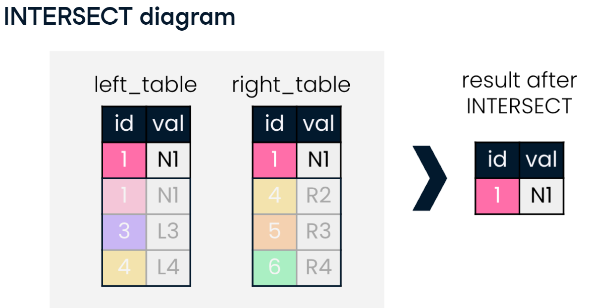

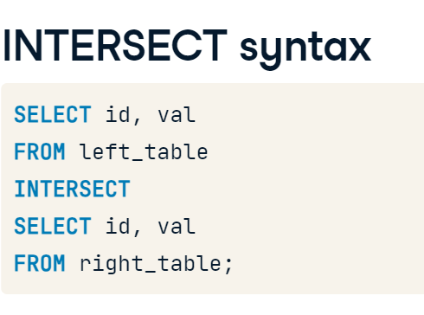

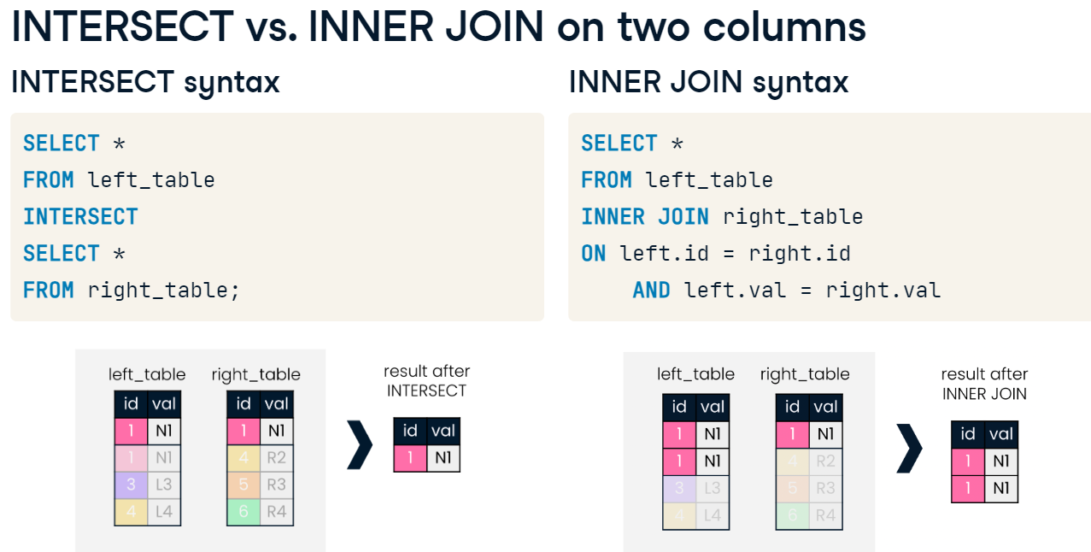

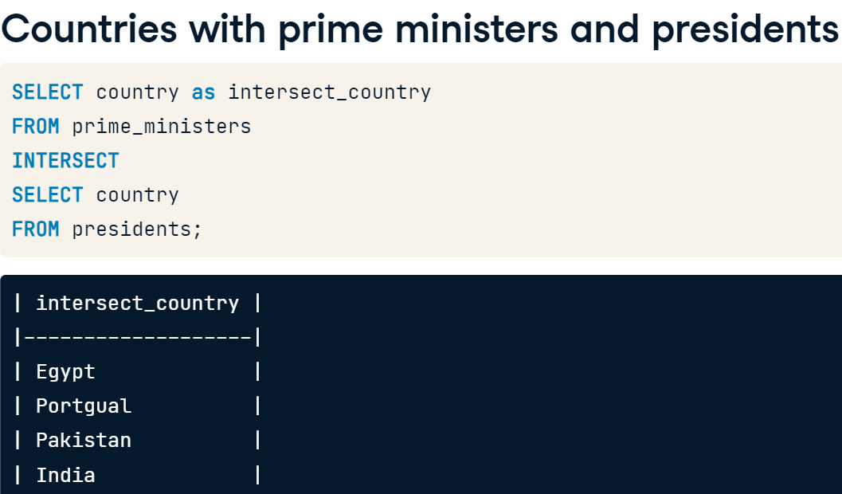

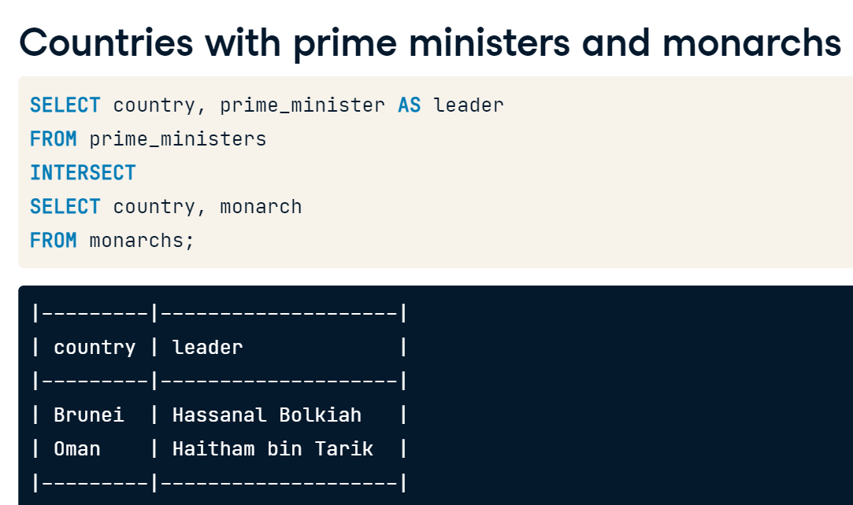

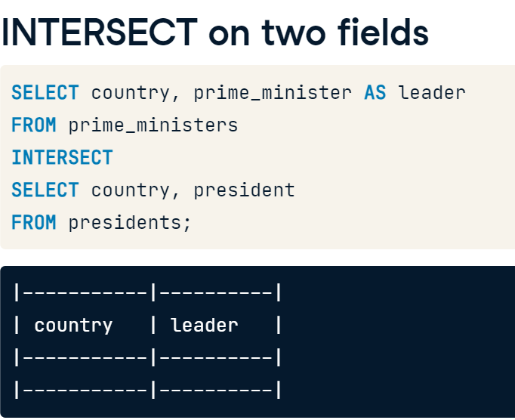

# INTERSECT

Well done getting through the material on INTERSECT!

Let's say you are interested in those countries that share names with cities. Use this task as an opportunity to show off your knowledge of set theory in SQL!

* Return all city names that are also country names.
* -- Return all cities with the same name as a country
* SELECT name
* FROM cities
* INTERSECT
* SELECT name
* FROM countries;

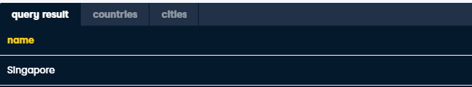



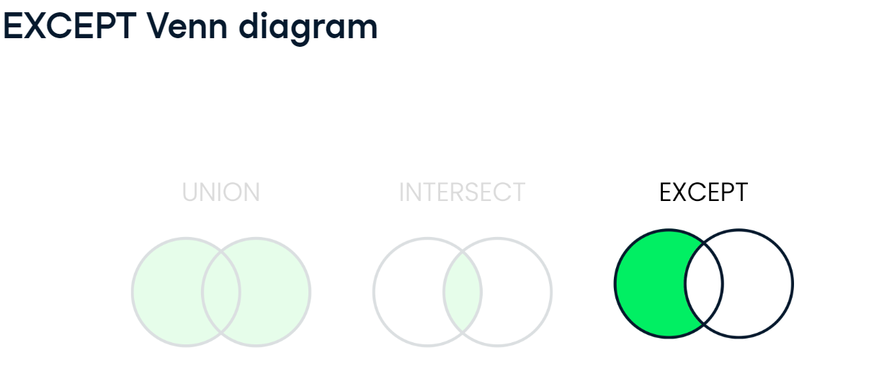

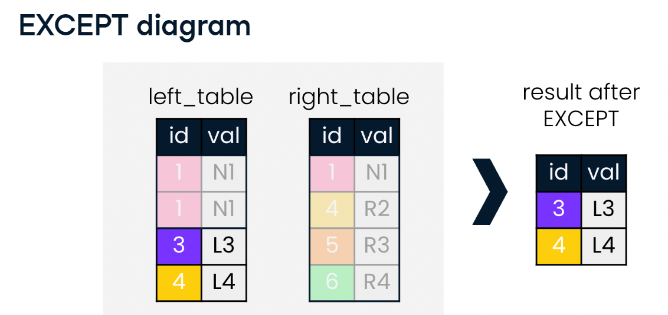

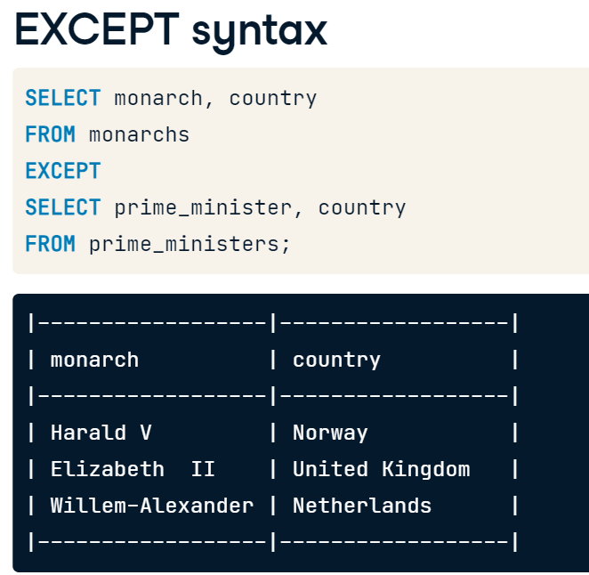

# You've got it, EXCEPT...

Just as you were able to leverage INTERSECT to find the names of cities with the same names as countries, you can also do the reverse, using EXCEPT.

In this exercise, you will find the names of cities that do not have the same names as their countries.

-- Return all cities that do not have the same name as a country

SELECT name

    FROM cities

EXCEPT

SELECT name

    FROM countries

ORDER BY name;

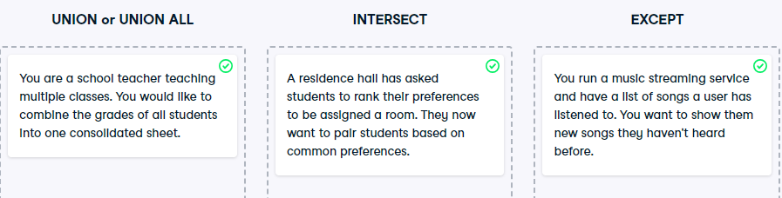

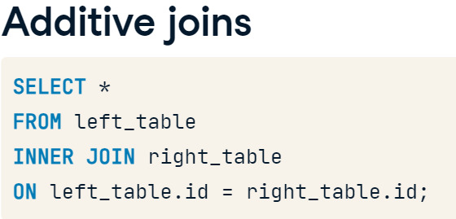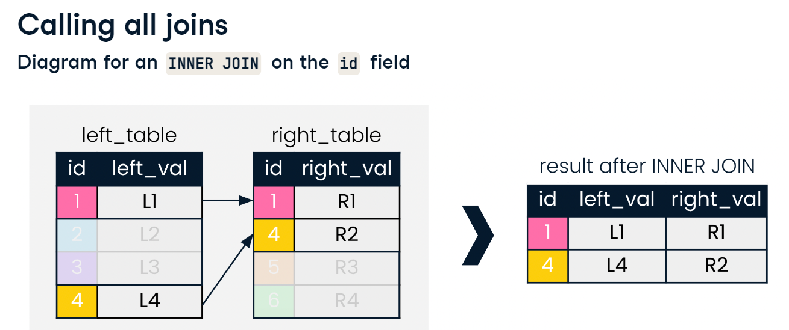

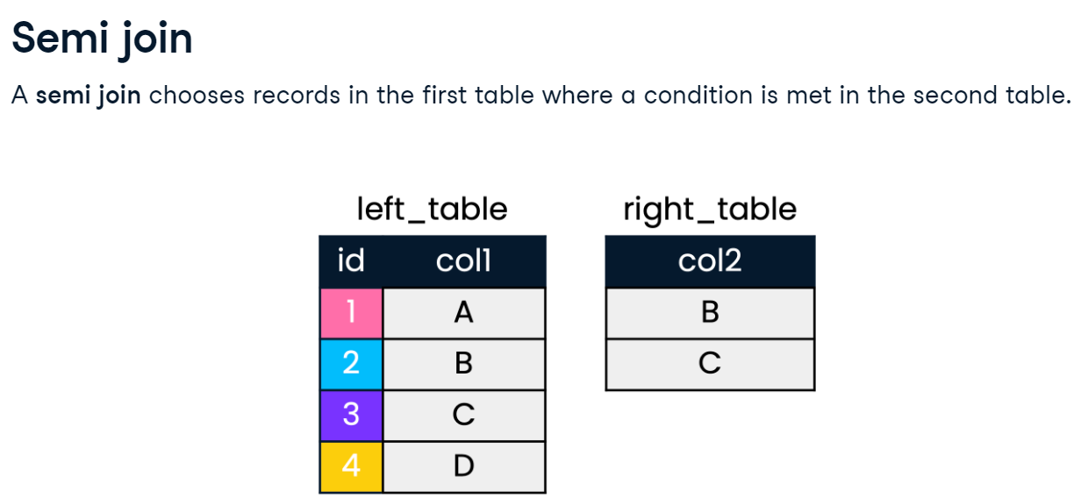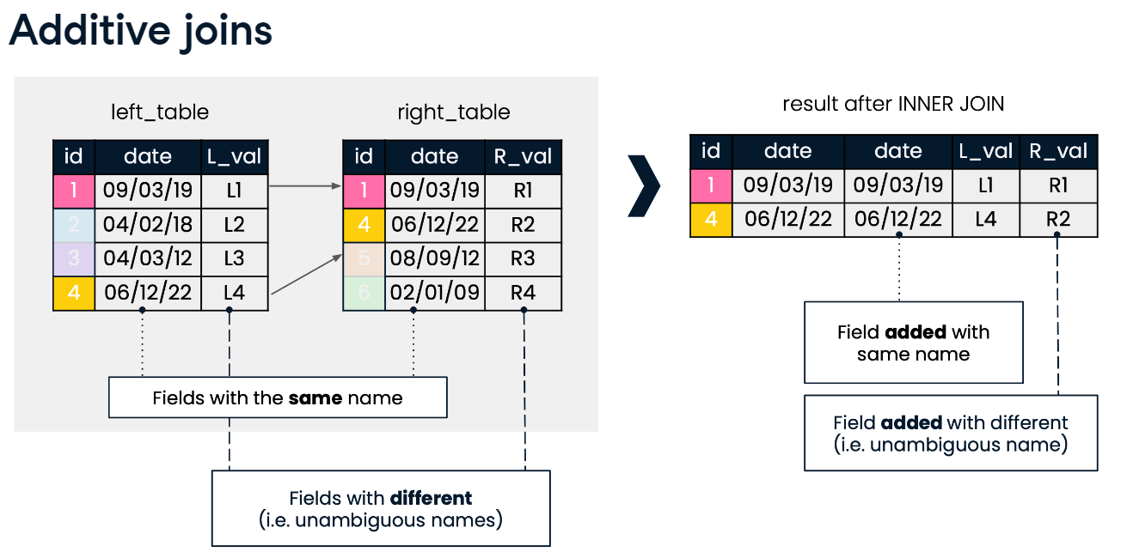

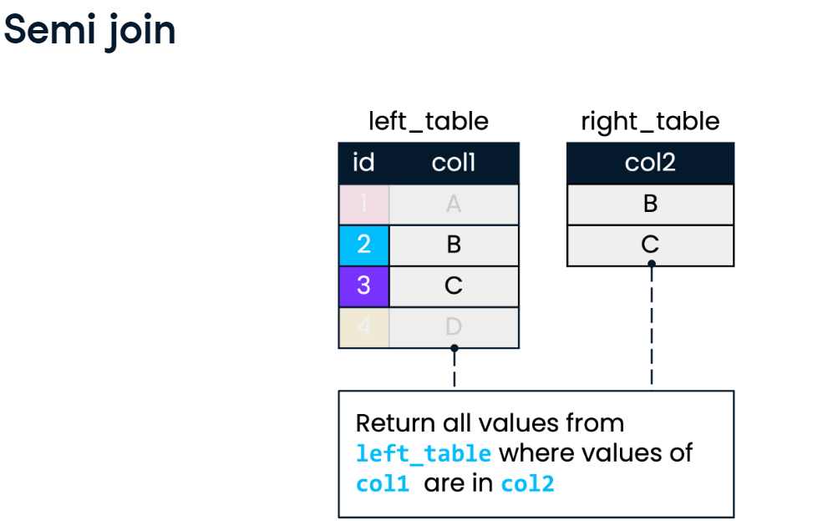

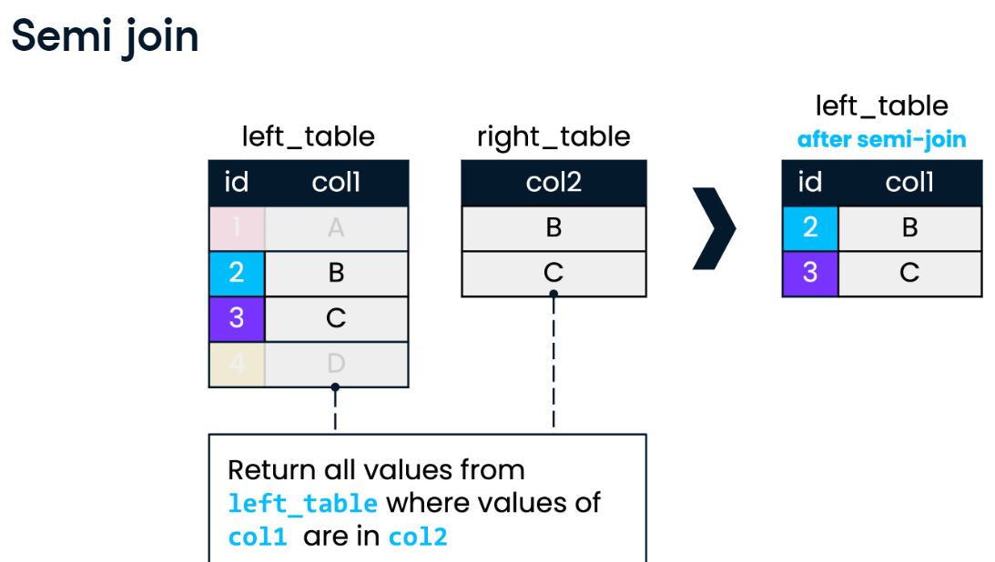

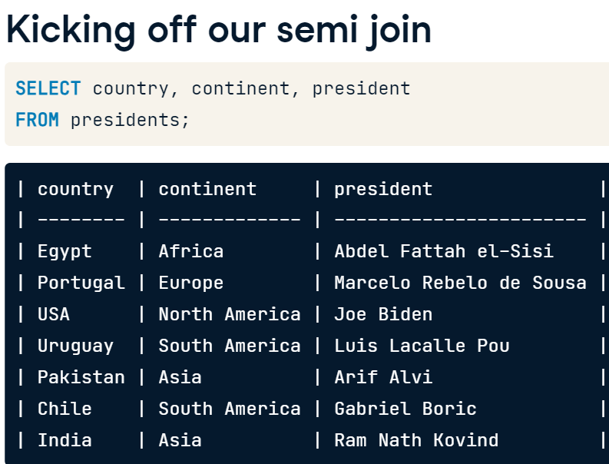

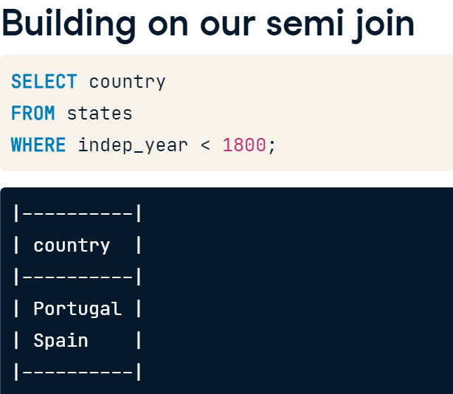

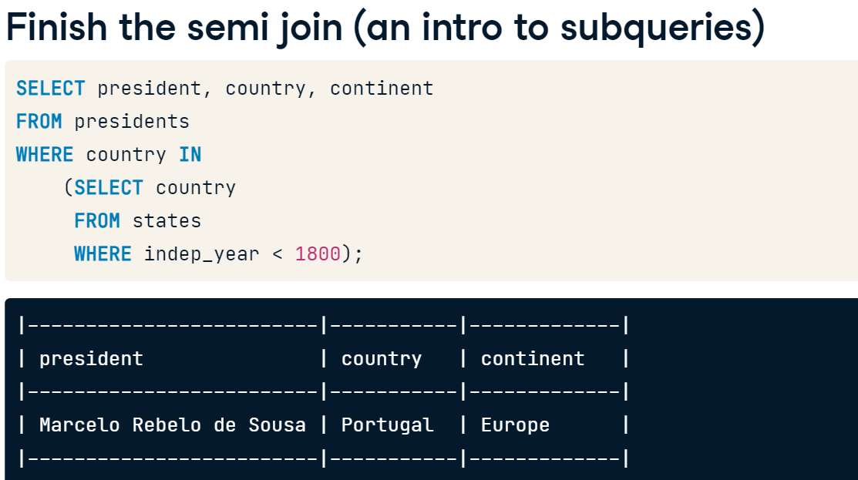

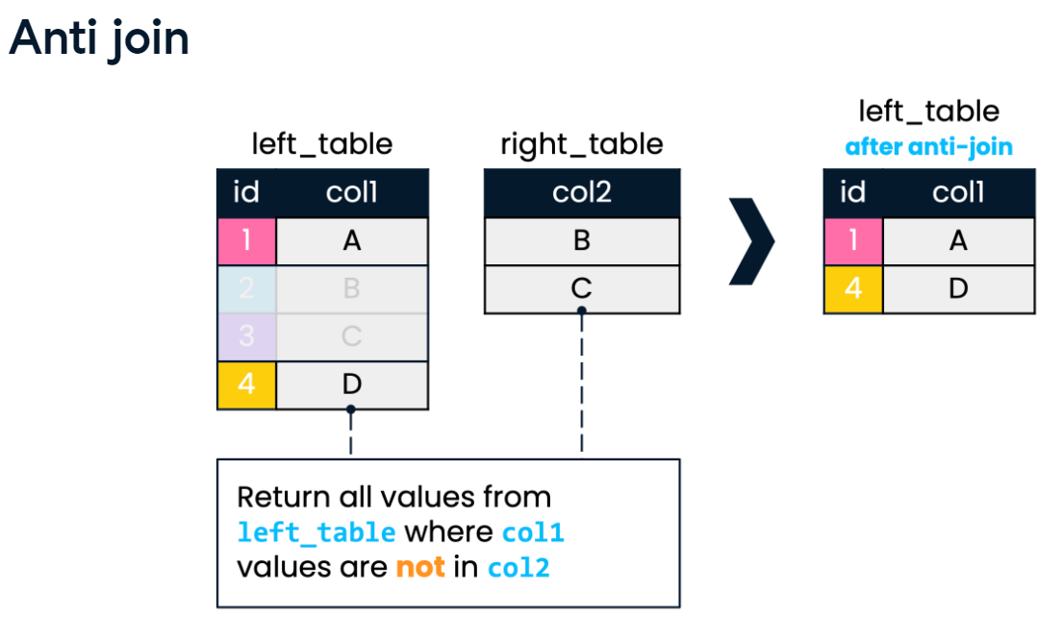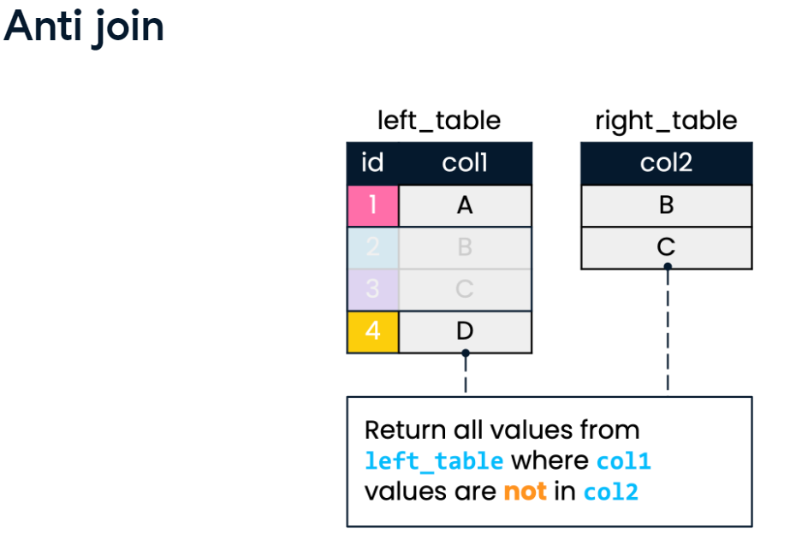

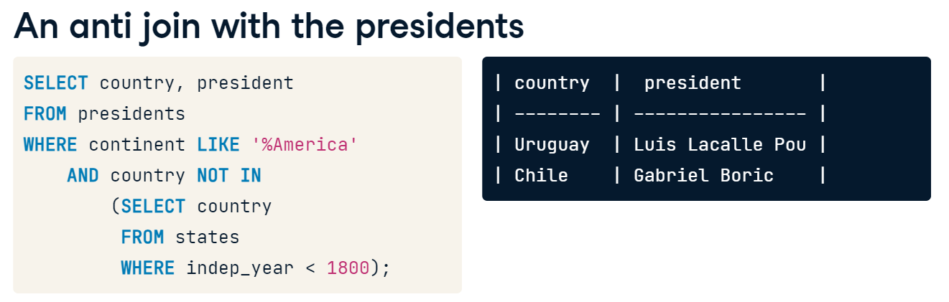

# Semi join

Great job getting acquainted with semi joins and anti joins! You are now going to practice using semi joins.

Let's say you are interested in identifying languages spoken in the Middle East. The languages table contains information about languages and countries, but it does not tell you what region the countries belong to. You can build up a semi join by filtering the countries table by a particular region, and then using this to further filter the languages table.

You'll build up your semi join as you did in the video exercise, block by block, starting with a selection of countries from the countries table, and then leveraging a WHERE clause to filter the languages table by this selection.

* Select country code as a single field from the countries table, filtering for countries in the 'Middle East' region.
* -- Select country code for countries in the Middle East
* SELECT code
* FROM countries
* where region = 'Middle East';
* Write a second query to SELECT the name of each unique language appearing in the languages table; do not use column aliases here.
* Order the result set by name in ascending order.
* -- Select unique language names
* ___
* FROM languages
* -- Order by the name of the language
* ___;

-- Select unique language names

SELECT distinct name

FROM languages

-- Order by the name of the language

Order by name;

* Create a semi join out of the two queries you've written, which filters unique languages returned in the first query for only those languages spoken in the 'Middle East'.

SELECT DISTINCT name

FROM languages

-- Add syntax to use bracketed subquery below as a filter

WHERE code in

    (SELECT code

    FROM countries

    WHERE region = 'Middle East')

ORDER BY name;

# Diagnosing problems using anti join

Nice work on semi joins! The anti join is a related and powerful joining tool. It can be particularly useful for identifying whether an incorrect number of records appears in a join.

Say you are interested in identifying currencies of Oceanian countries. You have written the following INNER JOIN, which returns 15 records. Now, you want to ensure that all Oceanian countries from the countries table are included in this result. You'll do this in the first step.

SELECT c1.code, name, basic_unit AS currency

FROM countries AS c1

INNER JOIN currencies AS c2

ON c1.code = c2.code

WHERE c1.continent = 'Oceania';

If there are any Oceanian countries excluded in this INNER JOIN, you want to return the names of these countries. You'll write an anti join to this in the second step!

* Begin by writing a query to return the code and name (in order, not aliased) for all countries in the continent of Oceania from the countries table.
* Observe the number of records returned and compare this with the provided INNER JOIN, which returns 15 records.
* -- Select code and name of countries from Oceania
* Select code, name,continent
* FROM countries
* where continent in
* ( Select continent
* FROM countries
* where continent='Oceania'
* )
* ;
* Begin by writing a query to return the code and name (in order, not aliased) for all countries in the continent of Oceania from the countries table.

-- Select code and name of countries from Oceania

SELECT code, name

FROM countries

WHERE continent = 'Oceania';

* Now, build on your query to complete your anti join, by adding an additional filter to return every country code that is **not** included in the currencies table.
* SELECT code, name
* FROM countries
* WHERE continent = 'Oceania'
* AND code NOT IN (
* SELECT code
* FROM currencies
* )
* LIMIT 5;

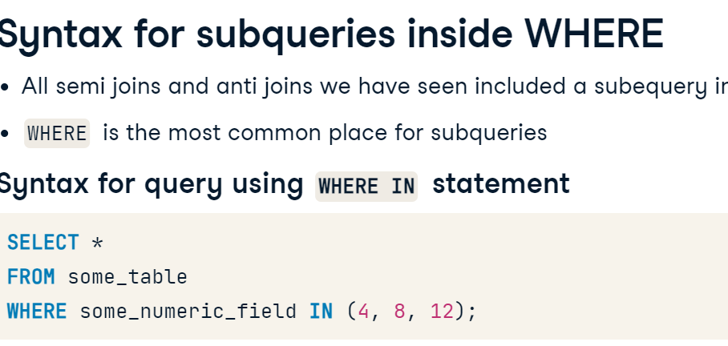

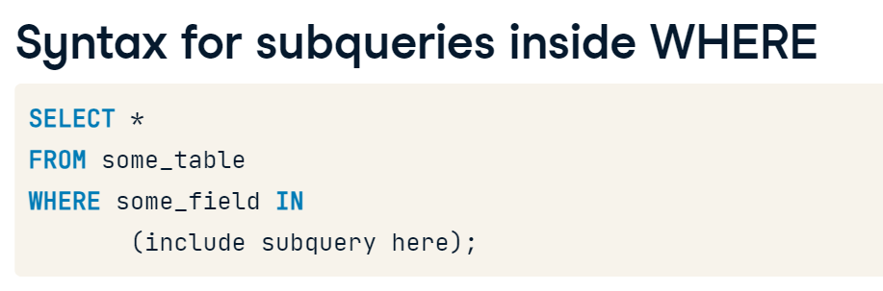

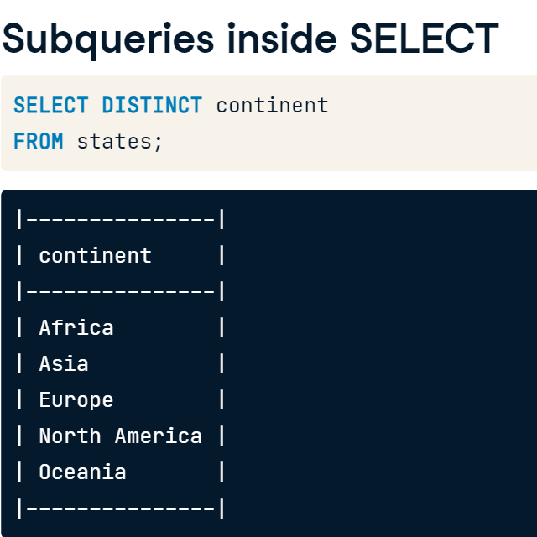





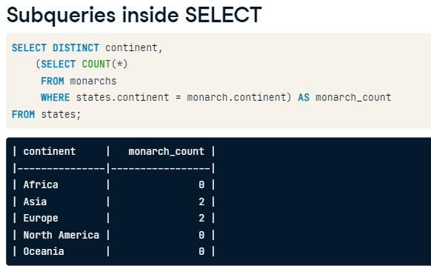

# Subquery inside WHERE

The video pointed out that subqueries inside WHERE can either be from the same table or a different table. In this exercise, you will nest a subquery from the populations table inside another query from the same table, populations. Your goal is to figure out which countries had high average life expectancies in 2015.

You can use SQL to do calculations for you. Suppose you only want records from 2015 with life_expectancy above 1.15 * avg_life_expectancy. You could use the following SQL query.

SELECT *

FROM populations

WHERE life_expectancy > 1.15 * avg_life_expectancy

AND year = 2015;

In the first step, you'll write a query to calculate a value for avg_life_expectancy. In the second step, you will nest this calculation into another query.

* Begin by calculating the average life expectancy from the populations table.
* Filter your answer to use records from 2015 only.
* The answer from your query has now been nested into another query; use this calculation to filter populations for all records where life_expectancy is 1.15 times higher than average.
* SELECT *
* FROM populations
* -- Filter for only those populations where life expectancy is 1.15 times higher than average
* WHERE life_expectancy > ___
* (SELECT AVG(life_expectancy)
* FROM populations
* WHERE year = 2015)
* AND year = 2015;

SELECT *

FROM populations

-- Filter for only those populations where life expectancy is 1.15 times higher than average

WHERE life_expectancy*1.15 >

  (SELECT AVG(life_expectancy)

   FROM populations

   WHERE year = 2015)

    AND year = 2015;

SELECT *

FROM populations

  WHERE life_expectancy >

    (SELECT AVG(life_expectancy) * 1.15

      FROM populations

        WHERE year = 2015)

  AND year = 2015;

# WHERE do people live?

In this exercise, you will strengthen your knowledge of subquerying by identifying capital cities in order of largest to smallest population.

Follow the instructions below to get the urban area population for capital cities only. You'll use the countries and cities tables displayed in the console to help identify columns of interest as you build your query.

* Return the name, country_code and urbanarea_pop for all *capital* cities (not aliased).
* SELECT name, country_code, urbanarea_pop
* FROM cities
* WHERE country_code IN (
* SELECT code
* FROM countries
* WHERE capital = cities.name
* )
* ORDER BY urbanarea_pop DESC;

# Subquery inside SELECT

As explored in the video, there are often multiple ways to produce the same result in SQL. You saw that subqueries can provide an alternative to joins to obtain the same result.

In this exercise, you'll go further in exploring how some queries can be written using either a join or a subquery.

In Step 1, you'll begin with a LEFT JOIN combined with a GROUP BY to select the nine countries with the most cities appearing in the cities table, along with the counts of these cities. In Step 2, you'll write a query that returns the same result as the join, but leveraging a nested query instead.

* Write a LEFT JOIN with countries on the left and the cities on the right, joining on country code.
* In the SELECT statement of your join, include country names as country, and count the cities in each country, aliased as cities_num.
* Sort by cities_num (descending), and country (ascending), limiting to the first nine records.
* SELECT countries.name AS country, COUNT(cities.name) AS cities_num
* FROM countries
* LEFT JOIN cities ON countries.code = cities.country_code
* GROUP BY countries.name
* ORDER BY cities_num DESC, country ASC
* LIMIT 9;
* Complete the subquery to return a result equivalent to your LEFT JOIN, counting all cities in the cities table as cities_num.
* Use the WHERE clause to enable the correct country codes to be matched in the cities and countries columns.
* SELECT countries.name AS country,
* -- Subquery that provides the count of cities
* (SELECT ___
* FROM cities
* WHERE ___) AS cities_num
* FROM countries
* ORDER BY cities_num DESC, country
* LIMIT 9;

SELECT countries.name AS country,

-- Subquery that provides the count of cities

  (SELECT count(cities.name)

   FROM cities

   WHERE cities.country_code=countries.code) AS cities_num

FROM countries

ORDER BY cities_num DESC, country

LIMIT 9;



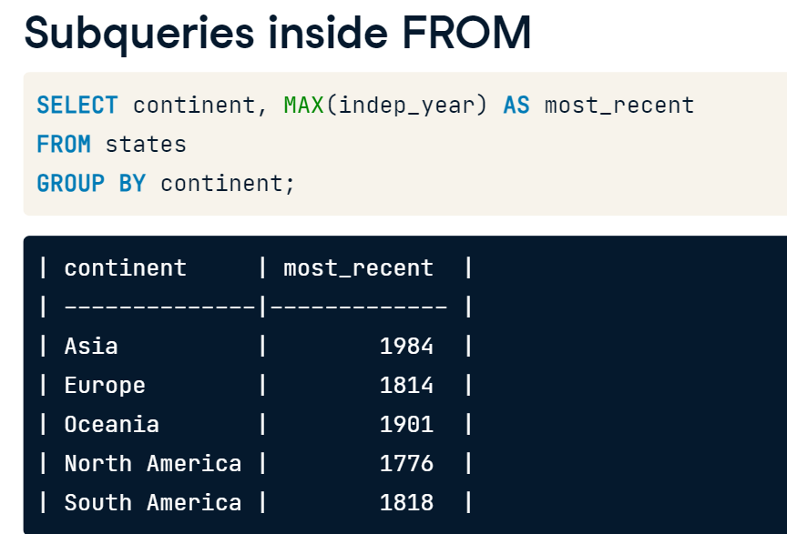

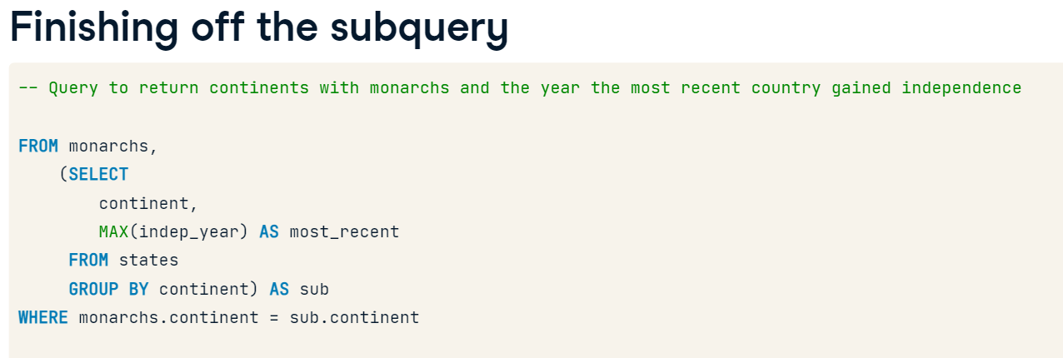 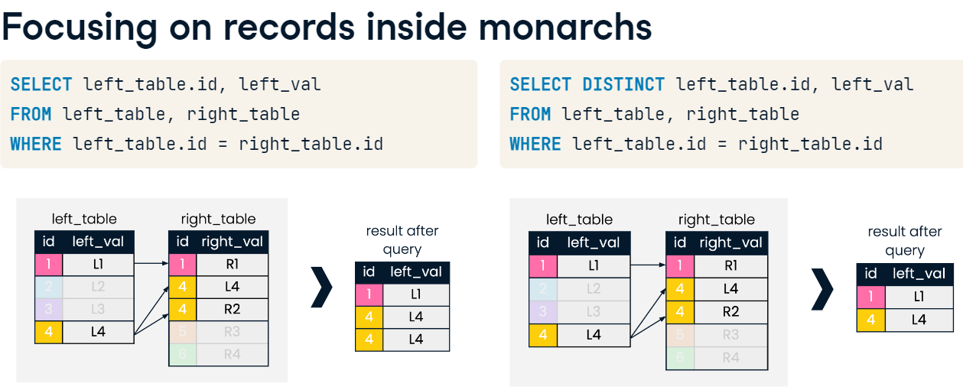

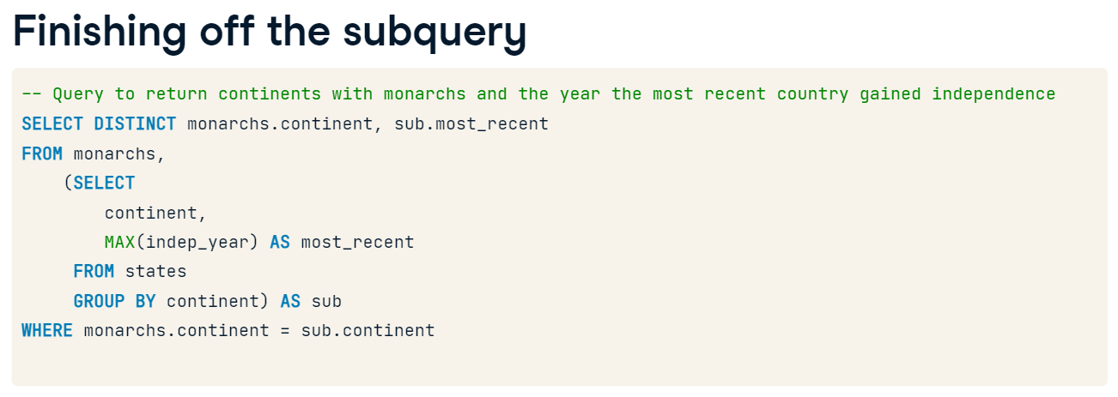

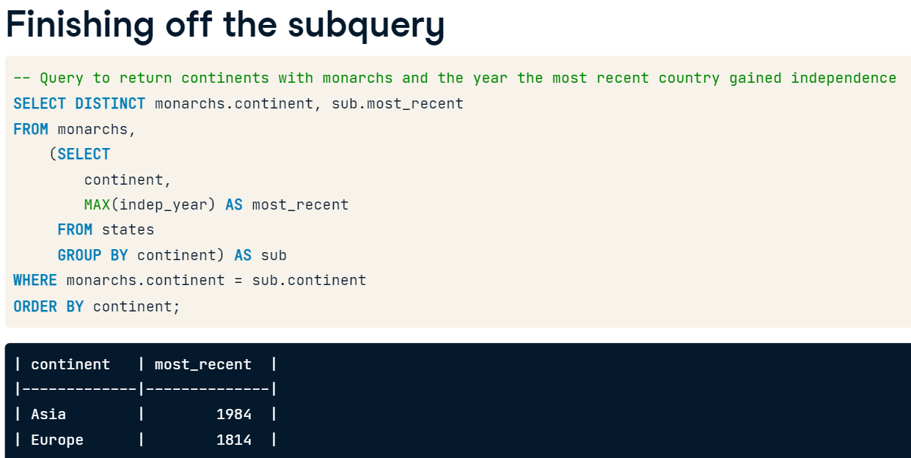



# Subquery inside FROM

Subqueries inside FROM can help select columns from multiple tables in a single query.

Say you are interested in determining the number of languages spoken for each country. You want to present this information alongside each country's local_name, which is a field only present in the countries table and not in the languages table. You'll use a subquery inside FROM to bring information from these two tables together!

* Begin with a query that groups by each country code from languages, and counts the languages spoken in each country as lang_num.
* In your SELECT statement, return code and lang_num (in that order).
* -- Select local_name and lang_num from appropriate tables
* select local_name,sub.lang_num
* from countries,
* (SELECT code, COUNT(*) AS lang_num
* FROM languages
* GROUP BY code) AS sub
* -- Where codes match
* Where countries.code = sub.code
* ORDER BY lang_num DESC;

# Subquery challenge

You're near the finish line! Test your understanding of subquerying with a challenge problem.

Suppose you're interested in analyzing inflation and unemployment rate for certain countries in 2015. You are **not** interested in countries with "Republic" or "Monarchy" as their form of government, but are interested in all other forms of government, such as emirate federations, socialist states, and commonwealths.

You will use the field gov_form to filter for these two conditions, which represents a country's form of government. You can review the different entries for gov_form in the countries table.

* Select country code, inflation_rate, and unemployment_rate from economies.
* Filter code for the set of countries which do not contain the words "Republic" or "Monarchy" in their gov_form.
* -- Select relevant fields
* select code, inflation_rate, unemployment_rate
* from economies
* WHERE year = 2015
* AND code NOT IN
* -- Subquery returning country codes filtered on gov_form
* (select code
* from countries
* WHERE gov_form LIKE '%Republic%' OR
* gov_form LIKE '%Monarchy%')
* ORDER BY inflation_rate;

SELECT name, country_code, city_proper_pop, metroarea_pop,

       city_proper_pop / metroarea_pop * 100 AS city_perc

FROM cities

WHERE name IN (

    SELECT capital

    FROM countries

    WHERE continent LIKE '%America' OR continent = 'Europe'

)

AND metroarea_pop IS NOT NULL

ORDER BY city_perc DESC

LIMIT 10;

